Development of a Fingerprint-Authenticated E-Voting System to Strengthen Electoral Integrity in the UK
Alexander J. Gordon
ID: 2502331
AC40001 Honours Project
BSc (Hons) Computing Science
University of Dundee, 2026
Supervisor: Oluwafemi Samuel

Abstract – The UK's current voting system relies on paper ballots and manual counting, leaving it vulnerable to voter impersonation, ballot tampering, and slow results. This project aims to design and develop a fingerprint authenticated electronic voting system to address these weaknesses while preserving the secrecy of the ballot. The system consists of two desktop applications and a cloud-hosted server, allowing polling station staff to manage devices and voters to authenticate and cast their ballot using their fingerprint. Security measures including encryption at rest, encrypted transmission, and anonymous vote storage were integrated throughout. Two rounds of user evaluation were conducted, with feedback driving a significant redesign of the voting staff interface. The results demonstrate that the system is functional and the voting process intuitive for users. If work were to continue, the most important next steps would be improving accessibility for users with degraded fingerprints, scaling the server to handle national level traffic, and ensuring full compliance with UK GDPR data retention requirements before deployment.
The testing and system code can be accessed via the following GitHub link:
https://github.com/Pronamel/Fingerprint-Authenticated-E-Voting-System.git

1. Introduction
While many nations have modernised their electoral systems, the UK has retained its long-established paper-based approach, continuing to rely on manual ballots and counting despite the vulnerabilities inherent in this method. Voter impersonation remains difficult to detect under the current identification model, manual counting introduces delays and opportunities for human error, and postal voting presents documented risks of undue influence and misrepresentation. These limitations highlight the need for a more secure and efficient approach to voter authentication and ballot handling.
In response to these challenges, this project aims to design and evaluate an electronic voting system that enhances voter authentication through biometric verification and safeguards user information through encryption and database structure. By mitigating the risks of ballot tampering and impersonation, and by removing delays associated with manual counting, the proposed system seeks to deliver a more secure, reliable, and efficient voting process.
Biometric authentication addresses these vulnerabilities by verifying identity in a way that cannot be easily forged or transferred. Unlike a signature or a photo ID card, a fingerprint is unique to the individual and cannot be lent, stolen, or replicated under normal circumstances. Integrating fingerprint authentication into the voting process therefore removes dependency on forgeable identifiers and ensures that only a registered voter can cast a ballot in their name. Crucially, this verification can be performed without linking the vote itself to the voter, preserving the secrecy of the ballot that is fundamental to democratic elections.
The system developed for this project, referred to throughout as the Biometric E-Voting System, comprises three integrated components. The Official App is operated by polling station staff and enables device management, voter registration, and real-time monitoring of station activity. The SecureVote App is used by voters at the polling terminal to authenticate via fingerprint and cast their ballot. A cloud-hosted server coordinates all communication between the applications, performs fingerprint matching, and stores votes in a manner that prevents any link to individual voters.
The Research and Background stage of this project established the limitations of the current UK voting system and examined international precedents in electronic and biometric voting, with particular attention to the systems implemented in Brazil and India [1][2]. This phase also included an in-depth review of available biometric technologies, alongside the ethical, legal, and accessibility considerations that any such system must address.
Building on this foundation, the Specification and Design stage defined the system’s functional and non-functional requirements using a MoSCoW prioritisation framework. High-fidelity interface mock-ups for both applications were produced to guide development and to gather early user feedback on usability and layout.
The Implementation stage proceeded iteratively, beginning with the database layer, followed by server development, and concluding with the two client applications. Security features such as encryption at rest, transport-layer protection, and biometric matching were integrated alongside to ensure information protection and user verification across the system.
Finally, the Evaluation stage assessed the system through two rounds of user surveys conducted at different points in development. The findings informed a substantial redesign of the Official App interface and highlighted areas requiring further refinement before the system could be considered suitable for deployment.
Overall, this project demonstrates how biometric authentication and secure digital infrastructure can address long-standing weaknesses in the UK’s paper-based voting process. By integrating modern security measures with established electoral principles, it offers a framework for a more resilient and efficient voting system.

2. Background

2.1 Current System in the UK
A general election in the UK is a process by which the public elects the 650 Members of Parliament [9]. Elections are typically held every five years and involve around 48.21 million voters [9]. Before anyone can vote, they must be registered on the electoral roll, be aged 18 or over on polling day, and be a British, Irish, or qualifying Commonwealth citizen [9]. Since 2023, voters are also required to bring accepted photographic identification to their polling station [9].
The UK is divided into 650 constituencies, each representing a geographic area [9]. Each constituency elects one Member of Parliament (MP) [9]. Voters do not vote directly for a Prime Minister or party, but for a single candidate in their local constituency [9]. The candidate who receives the most votes wins the seat [9]. This is known as the First Past the Post (FPTP) system [9]. The party winning the most seats across all 650 constituencies forms the government, with its leader becoming Prime Minister [9].
For most people, casting a ballot means visiting their designated polling station on election day, which runs from 7am to 10pm [9]. Upon arrival, voters present their photo ID, give their name and address to staff, and are handed a ballot paper [9]. The voter then enters a private booth, marks a single ‘X’ next to their chosen candidate, and places the completed ballot in a sealed box [9]. The entire process is supervised, ensuring the secrecy of each vote [9].
Voters unable to attend a polling station can apply for a postal vote, which is available to anyone upon request [9]. A ballot paper is sent to the voter's registered address, marked, and returned by post or hand before polls close [9].
Once polls close, ballot boxes are transported to central counting venues. Results are announced constituency by constituency, with the national picture typically becoming clear in the early hours of the following morning.

2.2 Limitations of Current Voting System
Prior to development of the system, it was critical to establish the necessity of a biometric electronic voting system in the UK. Three key problems were found within the UK electoral system: voter impersonation, ballot tampering and slow vote counting [15] [6]. The UK continues to rely heavily on paper ballots and manual counting, a voting system that has changed very little since 1888 (Electoral Commission, 2025; Open Rights Group, 2025) [7]. While confirmed cases of postal vote impersonation are reported to be very low, with under 1000 being convicted between 2008 to 2013, the current system makes impersonation difficult to detect or prove [6]. This is due to voters typically being identified only by name, address and signature [6]. An additional concern with postal voting relates to language barriers, whereby voters who require assistance may depend on third parties for interpretation, thereby increasing the risk of undue influence or misrepresentation in the casting of the ballot [6]. Furthermore, family pressure can heavily influence a voter’s choice when the family are able to see each other’s ballots [6]. All these factors make it impossible to ignore an issue with its security and authenticity of the current voting system in the UK.
Ballot tampering is also a concern due to the physical handling of paper ballots, particularly during transportation and counting [6]. Although safeguards exist, reliance on human handling introduces the possibility of error or misconduct [6]. Additionally, manual counting of millions of ballots is costly and time consuming, with recounts in close elections further delaying results, increasing costs and creating uncertainty that can lead to challenges to electoral integrity [8].
Public trust is essential to the effective functioning of government. Unexpected delays or perceived weaknesses in election security can reduce confidence in outcomes, even when no wrongdoing has occurred. In a modern country such as the UK, a voting system that appears slow or outdated risks increasing public suspicion and disengagement.

2.3 Existing Electronic Voting Systems
After identifying the limitations inherent in the British voting system, the researcher examined biometric electronic voting (E-voting) models already developed and implemented by governments internationally. Among the systems reviewed, the biometric E-voting systems adopted in Brazil and India were determined to be the most relevant for comparative analysis. [1][3].

2.3.1 India
India currently uses an electronic voting system without biometric authentication, choosing not to integrate the Aadhaar system alongside it [3]. Aadhaar is India’s national biometric identification programme, which holds fingerprint, iris, and facial data for over one billion citizens linked to a unique 12 digit identification number [2]. However, the Aadhaar system was excluded from consideration due to its reliance on a centralised database, which creates the potential to link an individual voter to their ballot, thereby compromising the anonymity of the electoral process [3]. A further vulnerability of this centralised architecture is its susceptibility to linkage attacks, in which information from multiple datasets can be combined to re-identify individuals within anonymised records [3]. Owing to these risks, particularly the threat to constitutional privacy protections and the possibility that biometric linkage could undermine the secrecy of the ballot, the Indian government determined that Aadhaar was too insecure to be fully integrated into the national voting system [3]. In addition to rejecting its use in elections, the government subsequently imposed restrictions on the scope of Aadhaar’s application in other domains [3].

2.3.2 Brazil
Unlike India, Brazil fully integrated biometric fingerprint authentication into their electronic voting system, known as the Urna Eletrônica [1]. Brazil's transition to this system was not immediate, but rather a staged process spanning over a decade. The country first moved away from paper ballots entirely in 2000, becoming the first nation to conduct elections fully electronically [1]. Biometric authentication was then introduced as a separate layer, piloted in 2008 across three municipalities before being integrated into a new biometric capable voting system in 2012 [1]. This phased approach allowed the infrastructure to mature before biometrics were added, reducing the risk of failure [1].
The electronic system dramatically increased the speed of vote counting, with results available within hours of polls closing across a country of over 200 million voters [1]. The system also demonstrated strong accessibility considerations, incorporating audio guidance for visually impaired voters [1].
However, the Brazilian system also presented notable shortcomings. A significant weakness identified was the incomplete biometric coverage of the electorate; not all voters had been biometrically registered, meaning manual identification checks remained as a fallback, undermining the consistency of the biometric layer [1]. A further concern was the absence of a paper audit trail, as critics argued there was no independent mechanism for voters to verify their vote had been correctly recorded, raising transparency concerns [1]. Additionally, fingerprint recognition accuracy was found to be unreliable for elderly voters and those with manual occupations. This is due to natural fingerprint degradation resulting in failed authentications at the polling station [1]. The centralised nature of the biometric database also raised privacy concerns, echoing some of the issues identified in the Indian Aadhaar system [1].

2.4 Overview of Biometric Scanner Technologies
The literature identifies three biometric methods as the most widely researched and deployed options for identity verification in electronic voting systems: fingerprint scanning, facial recognition, and iris scanning [12]. Evaluations of these technologies typically focus on performance metrics such as the False Acceptance Rate (FAR), which is central to assessing system reliability. In addition to the FAR, the analysis also considers the financial implications of each modality, as nationwide deployment necessitates substantial investment in specialised hardware and supporting infrastructure.
Biometric scanners themselves do not perform the comparison between a captured biometric and a stored reference. Instead, the scanner captures the biometric data and converts it into a digital template, with the comparison carried out by external matching software [18]. Research therefore emphasises that evaluating a biometric system requires assessing both the quality of the scanner and the performance of the matching software [12].
The key metric used to evaluate matching software performance is the FAR, which refers to the likelihood that the system incorrectly matches a captured template to a stored template belonging to a different individual [52]. A high FAR indicates an unreliable system unsuitable for security critical applications [12].
Scanner Type | Price Range (USD) | False Acceptance Rate Range (%)
Iris | 1500 – 3000 | 0.0001 – 0.01
Face | 1000 – 2500 | 0.1 – 1.0
Fingerprint | 200 – 1500 | 0.01 – 0.1
Table 1. Table depicting average price range and False Acceptance Rate range of various biometric scanner types [12][19].
Iris scanning is found to produce the lowest FAR of the three methods, sitting between 0.0001% and 0.01% [12]. This is attributed to the iris containing a significantly higher number of unique data points, giving the matching algorithm more information to work with. However, this complexity makes iris scanning computationally demanding, requiring deep neural networks to process captures effectively [13][15], which is reflected in hardware costs ranging from 1500 USD to 3000 USD per unit [19].
Facial recognition is found to be more affordable at 1000 USD to 2500 USD per unit [19], however the literature reports FAR values of 0.1% to 1.0% [12], significantly worse than iris scanning. Performance is further found to degrade under conditions such as occlusion, lighting variation, aging, and pose changes [14]. Facial recognition systems have also demonstrated vulnerability to spoofing attacks, with equal error rates reaching 8% in some advanced implementations [18].
Fingerprint scanning occupies a middle ground in the literature. At a cost of 200 USD to 1500 USD per unit [19], it is substantially cheaper than both alternatives. Matching software achieves FAR values of between 0.01% and 0.1% [12], and while environmental factors such as moisture can affect scan quality, research suggests these issues are manageable rather than fundamental limitations [16]. Capacitive scanners are noted as being considerably more resistant to spoofing than optical alternatives, due to detecting electrical conductivity rather than simply capturing an image [17]. However, recognition accuracy has been found to be unreliable for elderly voters and those in manual occupations, due to natural fingerprint degradation [1].
Brazil's large scale deployment of fingerprint biometrics within the Urna Eletrônica provides real world evidence of fingerprint authentication operating at national election scale, demonstrating its viability in reducing impersonation and electoral fraud [11].

2.5 Ethical Considerations
The incorporation of biometric data into public electoral systems raises substantial ethical concerns that warrant careful scrutiny. Unlike passwords or identification cards, biometric traits are inherently permanent and cannot be altered if compromised [31][32]. Consequently, a breach involving biometric identifiers may expose individuals to irreversible, lifelong risks, undermining the trust placed in the system by voters [31][32]. Under the UK General Data Protection Regulation (UK GDPR) and the Data Protection Act 2018, biometric data processed for the purpose of uniquely identifying a person is classified as special category data, needing the highest level of legal protection and requiring explicit justification for its processing [31][32]. The potential for data breach containing biometric data is one reason that biometric voting systems are distrusted. The literature identifies the centralised storage of biometric templates as a particular concern, as large, centralised databases present high value targets for attackers, and a successful breach would expose the biometric data of the entire electorate [32]. A further ethical concern identified relates to function creep, where biometric data collected for voting could be reused for surveillance or law enforcement without consent from the individual [32]. The Indian government's decision to reject the use of its Aadhaar biometric database in elections reflects these concerns [3][32]. The literature therefore suggests that any biometric voting system must incorporate strict data minimisation principles, clear limits of biometric use and strong legal safeguards.

2.6 Accessibility Considerations
Accessibility represents a significant practical and ethical challenge for biometric E-voting systems. Research highlights that electronic voting systems must be designed to accommodate the full range of the electorate, including elderly voters, those with physical disabilities, and individuals with limited digital literacy [1][33]. Fingerprint recognition in particular presents documented accessibility challenges, as studies have found that fingerprint quality degrades naturally with age and is further affected by certain medical conditions and manual occupations, leading to higher rates of failed authentication among these groups [1][33]. A system that fails to authenticate a legitimate voter effectively denies them their right to vote, which is a serious and unacceptable outcome in a democratic context. The Brazilian Urna Eletrônica addressed some accessibility concerns through the inclusion of audio guidance for visually impaired voters, demonstrating that accessibility features can be meaningfully integrated into biometric voting systems [1].

2.7 Public Trust of Electronic Voting
Public trust is as a critical and often underappreciated factor in the success or failure of electronic voting systems. Research has consistently shown that perceived fairness and transparency in electoral processes have a direct impact on voter confidence in democratic outcomes, regardless of if any actual wrongdoing has occurred [34][35]. The introduction of biometrics adds an additional dimension to public trust, as voters must have confidence not only that their vote is recorded correctly, but also that their biometric data is handled securely and will not be misused [34][35].

3. Specification

3.1 Aims and Objectives
The limitations outlined previously highlight several structural weaknesses in the UK’s current voting process. Reliance on paper ballots and manual counting creates vulnerabilities to voter impersonation, ballot tampering, and delays in producing results. These issues, combined with security concerns surrounding postal voting and the risk of declining public trust, form the foundation for the system requirements addressed in this project.
The aim of this project was therefore to design and develop a biometric e-voting system capable of addressing these limitations. The system must verify voter identity through fingerprint authentication before a vote is cast, removing dependence on easily forged identifiers such as signatures. Votes must be recorded digitally to eliminate risks associated with paper ballot handling and manual counting. Crucially, the system must also ensure that no vote can be linked back to the individual who cast it, preserving voter anonymity in line with UK electoral principles.
To deliver this system, three core components must be developed and integrated. The Official App functions as the central interface within a polling station, enabling staff to manage voting devices, register voters, and access information appropriate to their permissions. The Voting App guides voters through authentication and the voting process at the polling terminal. Finally, the server manages all encrypted communication between the applications, processes fingerprint templates to verify voters and officials, performs predefined data operations, and stores votes anonymously.

3.2 Methodology
The methodology chosen for development of the project was a loose Agile approach. The methodology had to be adapted to allow for solo development within an academic setting. The Waterfall methodology was considered as an alternative but was rejected due to its phase locked structure, which makes it poorly suited to projects where requirements are likely to evolve during development [57]. In a Waterfall model, changes identified during implementation require returning to earlier phases, introducing significant delays if a new requirement is identified [57]. Given that design decisions around biometric integration and system security were almost guaranteed to change during development, Agile's iterative and flexible nature was deemed more appropriate, allowing changes to be incorporated without disrupting overall progress [57].
As the project was an individual effort, certain Agile practices were not applicable. Team activities such as retrospectives and story point were therefore omitted [57]. Instead, the functional and non-functional requirements were used to produce a set of user stories that acted as the development backlog. These were prioritised using the MoSCoW method, which categorises requirements into Must Have, Should Have, Could Have, and Won't Have, establishing a clear minimum viable product early in the development phase and ensuring core features were delivered before additional functionality was considered [58]. The full list of prioritised requirements can be found in Appendix B.
During development, meetings were held with the project supervisor, with frequency varying depending on the stage of development (Appendix E). During periods where problems required guidance, meetings were held weekly. When development was progressing smoothly, meetings were held every two weeks. This flexible structure aligns naturally with Agile principles, allowing the pace of review to adapt to the needs of the project rather than following a rigid schedule [57].

3.3 User Stories
User stories were created from the functional and non-functional requirements with the purpose of keeping development focused on what was required. The user stories focused on the two main user types: Officials and Voters, and detailed what they expected the system to function. The user stories below are an example of key interactions each user must be able to complete. A full list is included in Appendix C.
Voter
- As a voter, I want to scan my fingerprint to verify my identity, so that the system can verify I am a registered voter and prevent anyone else from casting a vote in my name.
- As a voter, I want to be clearly informed if my fingerprint does not match and be given up to three attempts to authenticate, so that a failed scan due to a poor read does not immediately deny me my right to vote.
- As a voter, I want to view a clear list of candidates and select the one I wish to vote for, so that I can cast my ballot simply and without confusion.
- As a voter, I want to receive a clear confirmation message once my vote has been submitted, so that I can be confident my vote has been recorded and the process is complete.
Official
- As an official, I want to log in with my username and password and verify my identity with my fingerprint, so that only authorised officials can access and manage the polling station system.
- As an official, I want to generate an access code for my polling station and use it to link voter devices, so that I can ensure only devices within my station are connected to the correct election session.
- As an official, I want to register new voters onto the system including capturing their fingerprint, so that their biometric data is stored securely ahead of polling day and they are able to authenticate when they arrive.
- As an official, I want to lock and unlock individual voter devices remotely, so that I can intervene immediately if a problem arises at any device in the station.
- As an official, I want to be automatically notified if a voter fails fingerprint authentication three consecutive times, so that I can attend to the voter and determine whether an alternative verification method is required.

3.4 Project Plan
A Gantt chart was produced at the outset of the project to organise the development process into clearly defined phases with associated timescales (Appendix D). The plan provided a structured overview of the project from start to submission, allowing progress made to be tracked against the expectations set at the beginning of each phase. This aligned with the Agile approach, where supervisor meetings held on Fridays provided regular checkpoints to assess whether the project was on track and whether timescales needed to be adjusted. Meeting minutes were kept throughout the meetings with the supervisor and can be found in Appendix E.
The project ran from January to April 2026. January began with a focused research phase covering the two core technical areas underpinning the system, biometric authentication and encryption. These were prioritised at this stage because a significant number of the system's functional requirements could not be met without a thorough understanding of both. Running alongside this, an interim report was completed in January to present early findings and justify the initial design decisions made.
Following the interim report, the design phase began in late January and ran into February. This phase established the key architectural decisions for the system, including the three component structure of the Official App, Secure Vote App, and Server, and the selection of SourceAFIS as the fingerprint matching library. The design phase overlapped with the start of implementation to maintain development momentum.
Implementation began in mid-February, starting with the database. Defining the data structure at this early stage allowed the server and applications to be built progressively on a stable foundation, avoiding the need for significant integration changes later. The server was developed next, as it formed the central component responsible for data handling, fingerprint verification, and communication between the two applications. Development then progressed to the Official App and Secure Vote App, which were built to handle the user stories and interactive flows.
Security integration began at the end of March and continued through to late April, overlapping with the testing phase. This stage was deliberately allocated a substantial portion of the timeline given its critical nature and the researchers inexperience with it. Furthermore, an inadequate security implementation risked compromising the confidentiality of voter data and the secrecy of the ballot, both of which are fundamental requirements of the system. Testing was conducted throughout this phase to verify that encrypted communications and secure data handling functioned as intended.
The final report was written progressively throughout the project, with the final two weeks of April reserved for completing and reviewing the full submission.

4. Design

4.1.1 Transport Layer Security
The first area of security the researcher explored was transport layer security (TLS). TLS ensures that information sent over the internet is encrypted rather than transmitted in plaintext [20]. This is essential for securely transmitting biometric templates and other sensitive data between client and server in a biometric e-voting system.
Enabling HTTPS within the project presented a practical challenge, as obtaining a signed TLS certificate typically requires purchasing a registered domain name. After investigating alternatives, the researcher identified the use of nip.io, a wildcard DNS service that maps IP addresses to hostnames, combined with Nginx as a reverse proxy to handle TLS termination [36]. This approach allowed HTTPS to be configured without purchasing a domain, satisfying the transport security requirement within the constraints of the project. It is important to note that nip.io does not support wildcard certificates, thus the domain isn’t owned or validated by the system [36]. If the system was to be used at the intended scale across the UK, an officially owned domain with wildcard TLS certificate support is required to enable scalable and manageable service exposure [37].

4.1.2 Application Layer Encryption
It was identified that TLS alone is insufficient for a system handling highly sensitive biometric and personal data. While TLS protects data in transit, it does not protect the payload if the server itself is compromised. To address this, envelope encryption was explored as an additional layer of application level protection [26].
This approach encrypts the data before transmission and ensures that only the intended server can decrypt it, meaning sensitive data such as fingerprint PNG’s, voter lookups, and login credentials remain protected beyond the transport layer [26]. This significantly reduces the potential of data being exposed during transport and is essential when biometric data is being transported.

4.1.3 Data Protection at Rest
The researcher then investigated how personal voter data should be securely stored within the database. Storing data such as names, dates of birth, postcode, and biometric information in plaintext represents a critical vulnerability as a database breach would expose all voter information directly [38]. A further risk of databases being stored in plaintext is that developers working on the database would have access to the raw voter information, increasing the risk of a data leak.
AES-256-GCM was identified as an appropriate encryption standard due to its widespread adoption and strong security properties [21][26]. A ‘per voter’ encryption approach was selected, where each voter’s data is encrypted individually. This reduces the impact of a potential breach, as compromising one record does not expose others [21][39].
Key management was identified as a critical security consideration. Best practice dictates that encryption keys should be stored separately from the data they protect, typically using a dedicated secrets management service [21][40]. This requirement influenced the database design, requiring additional fields to accommodate encrypted data with its corresponding keys.
Not all fields require encryption. Fields such as County, Constituency, and ‘HasVoted’ are stored in plaintext, as they do not directly identify individuals. This allows efficient querying and reporting without unnecessary decryption overhead. This represents a deliberate trade-off between security and system usability.
For polling officials, partial protection was applied to the password field. Passwords are hashed rather than encrypted, as they do not need to be recovered, while usernames are stored in plaintext as they do not inherently contain sensitive information. Officials will be asked to not include personal information in their username.
Biometric data is stored in encrypted form and is only decrypted temporarily during comparison within server memory. It is never exposed in plaintext outside this context, ensuring that database access alone would not reveal usable biometric data.

4.1.4 Authentication and Access Control
The researcher investigated how to manage access across two distinct user roles within the system: voters and officials. JSON Web Tokens (JWT) were identified as a suitable mechanism for role-based authentication, allowing the server to verify identity and permissions on each request without maintaining session state [22][23]. Avoiding session state is beneficial as it removes the need for the server to store and manage user session data, allowing each request to be independently verified using a JWT, which reduces strain on the server.
Token expiry was identified as a critical security consideration. Shorter expiry windows reduce the risk of token misuse if compromised. As officials interact with the system for longer durations than voters, different expiry periods are applied depending on the user role [23].

4.1.5 Password Security
For polling officials, secure password storage is required. Modern password hashing algorithms were investigated and Argon2 was identified as the most suitable due to the salt [24]. Argon2 was selected due to its resistance to brute force and hardware accelerated attacks, making it suitable for protecting user credentials in a security critical system [24].

4.1.6 Database Lookup Protection
A further concern identified was the risk of exposing voter identity during database lookups. Sending plaintext identity fields such as name, date of birth, and postcode introduces the risk of interception or logging at the server layer.
To address this, searchable encryption techniques were explored. HMAC based token generation allows the system to perform lookups using a searchable deterministic index created from user information, without exposing the underlying plaintext data [25][59]. The searchable deterministic index enabled the system to use uniquely identifiable voter information to locate a fingerprint, without exposing personal data in plaintext during the process. The information used is first name, last name, date of birth, postcode and town of birth. The combination of this data makes the chance of collision extremely small.
The equations behind this statement are contained in the table below.
Function | Field | Probability
P(FN) | First name | $${ 3 ×10}^{-3}$$
P(Ln) | Last name | ${1 ×10}^{-3}$
P(DoB) | Date Of Birth | ${2.7 ×10}^{-5}$
P(PC) | Post Code | ${5.9 ×10}^{-7}$
P(ToB) | Town Of Birth | ${2 ×10}^{-4}$
Table 2. Formula used in the probability calculations [41][42][43][44][45][46][47][48].
The probability of a database record colliding with another is calculates as follows:
$$Probability of collision =$$
$$P(FN)×P(LN)×P(DoB)×P(PC)×P(ToB)$$
The resulting probability is$2.4 ×{10}^{-21}$. This is notably small and reduces the natural chances of a collision to almost 0. However, collisions arising from identical twins remain a realistic possibility, and this scenario has been accounted for and resolved within the system’s implementation.
An alternative approach would be to query using plaintext or directly encrypted fields. However, this was rejected due to the increased risk of sensitive data exposure during processing.
The National Insurance number is treated as an exception and is not used as a searchable. The reason for this is not all voters have a National Insurance number, but all votes need the information used in the searchable deterministic index to vote, thus National Insurance number was not used [9]. Figure 1 depicts the full authentication flow, including the system’s approach to resolving collisions through iteration of candidate records.
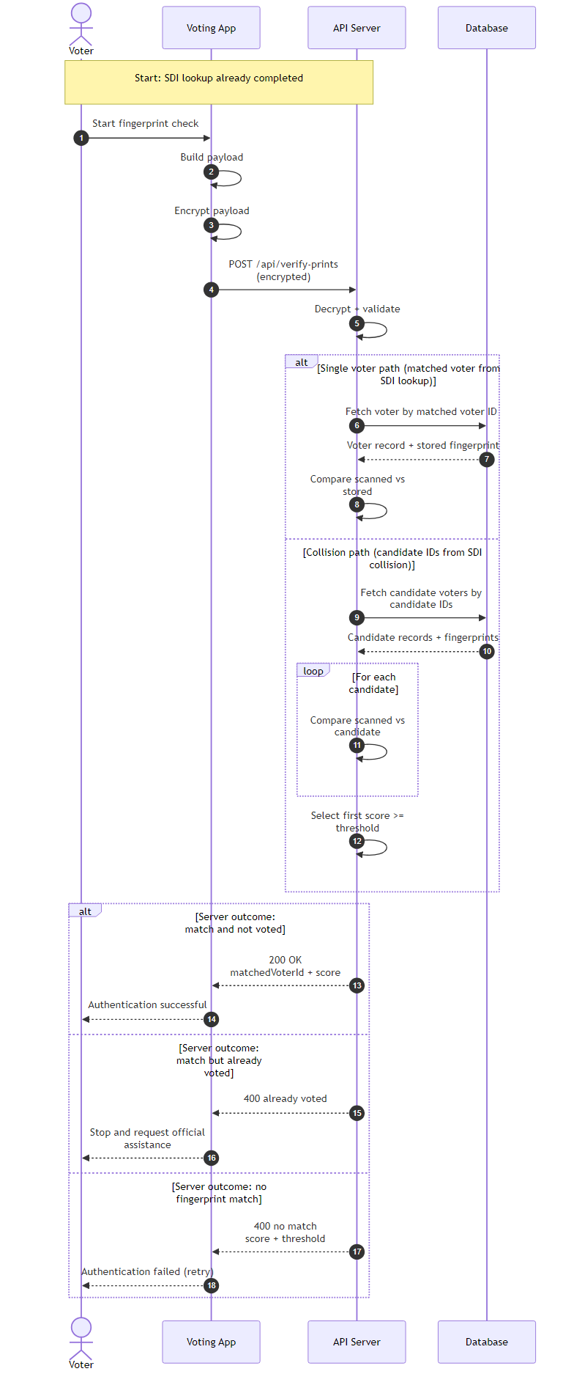
Figure 1. Sequence diagram of authentication flow as a voter.

4.1.7 Integrity of Linking Code
Session linking codes, used to associate sessions across system components, are hashed using SHA-256. SHA-256 was selected due to its computational efficiency, which is appropriate given that these codes are frequently regenerated as officials are instructed to change them each day [54].
Brute force attacks are not considered a practical concern in this context, as the codes rotate regularly, limiting the usefulness of any successful attack.

4.2 System Structure
The system consists of four main components: server, database, two client applications, and a hosting platform. The technologies selected for each component were chosen based on compatibility, security, and project constraints. Figure 2 presents the communication between the system’s components.
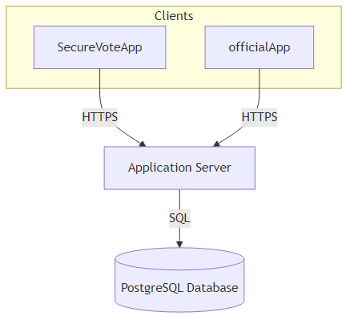
Figure 2. System architecture diagram.

4.2.1 Back-End
ASP.NET Core on .NET 8 was selected due to its cross platform compatibility and ability to support both API and application development within a single ecosystem [27]. As a long term support release, it benefits from ongoing security updates, making it suitable for a security critical system such as an e-voting platform.
Methods for communication between the server and clients were evaluated next. Initially, HTTP polling was considered due to its simplicity. However, it introduced latency and unnecessary network overhead. SignalR was selected instead, as it enables persistent, two way communication, allowing the server to push updates to clients in real time [28].
This approach improves responsiveness and ensures system state remains consistent across multiple active clients. The responsiveness was deemed essential as statuses are sent to the official app when issues occur on the voter device. The polling status messages were found to arrive 30 seconds after the status change had occurred, making warning statuses outdated. This encouraged the use of SignalR and its persistent connection to maintain the functionality of status updates.
A key design feature of the server is its channels. The SignalR channels are organised firstly by county and then by constituency. The channel structure is optimised to reduce lookup time, enabling quicker establishment of connections. This organisation also can be used to assign more server power to certain counties with a high number of connections, as a higher population a county might need more polling stations than others. This supports scalability, as system load can be distributed geographically without requiring architectural changes.
The active election configuration is hardcoded in the current implementation. While a dynamic configuration system would provide greater flexibility, it introduces a risk of accidental or malicious modification to negate election results. Hardcoding removes this risk and ensures changes require deliberate redeployment.

4.2.2 Front-End
Several front-end frameworks were evaluated for this system. WPF was rejected due to it only being compatible with Windows, and MAUI was discounted as its Linux desktop support was not production ready at the time of development. Avalonia was elected as the framework in this project. Avalonia is a cross platform User Interface (UI) framework for .NET that supports multiple operating systems from a single codebase, reducing development complexity and ensuring compatibility with the chosen backend technologies [29].
Alongside Avalonia, the researcher adopted the Model-View-ViewModel (MVVM) architectural pattern to structure the front end codebase. MVVM enforces a clear separation between the user interface (View), the application logic (ViewModel), and the underlying data (Model). This separation was particularly beneficial in this project as it allowed the user interface (UI) to be developed and modified independently of the logic, which proved valuable during the redesign phases driven by user feedback. Avalonia's native support for data binding made MVVM a natural fit, as ViewModels could expose properties and commands that the View binds to directly, reducing the need for code behind and keeping the interface logic clean and testable.
Usability was a key design consideration, as the system is intended for use across the UK’s population ranging from all technical ability. To support this, a simple and structured interface was designed, incorporating guided inputs and constrained controls where possible. This approach reduces user error and limits the range of acceptable input, which also contributes to minimising the system’s attack surface [49].
At the initial design stage, two key aspects guided the development process. The first was to create an intuitive UI that is accessible to users of all ages. The second was to minimise user input in order to reduce the system’s attack surface. To support these goals, high fidelity mock ups of both the voter and official application were produced. These were hand drawn on an iPad using Notability and are included in Appendix A.
The design of the mock ups followed the defined user stories (Appendix B), ensuring that the researcher remained focused on the system’s intended functionality while developing a user friendly interface. However, the first round of user surveys revealed several usability issues within the UI. In particular, the interface shown in Figure 3 was consistently identified by participants as complex, unclear, and visually cluttered. Based on this feedback, the researcher simplified this view.
Although the initial revisions focused primarily on improving Figure 3, feedback from the second round of surveys highlighted broader concerns regarding the not yet styled and inconsistent appearance of the interface. As a result, a more comprehensive redesign of the entire system was undertaken by the researcher using feedback from the surveys.
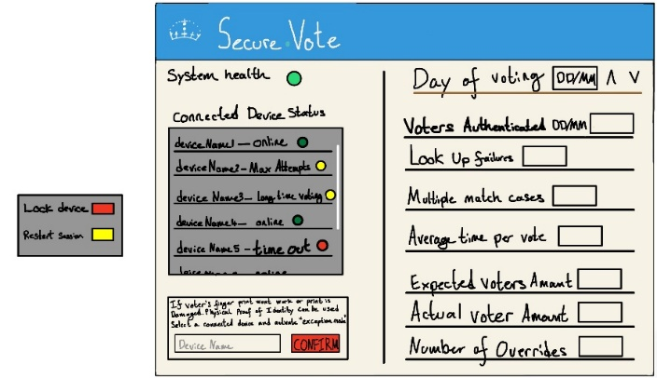
Figure 3. Official polling station management screen.

4.2.3 Database Design
PostgreSQL was selected as the database system due to its reliability, strong support for structured data, and compatibility with the chosen technology stack [30].
Entity Framework Core (EF Core) was used as the Object Relational Mapper, allowing interaction with the database through object oriented code rather than raw SQL queries [30]. This improves development efficiency and supports parameterised queries, reducing the risk of SQL injection. [30]
The system follows data minimisation principles, storing only the information required for identity verification and administration. Fields used for lookup are transformed into searchable indices, ensuring that sensitive data is not stored in plaintext while still allowing efficient queries.
The database schema was adapted to support the encryption model, reflecting how security requirements influenced the overall system design.
A key data design choice for this system is the reduction of information, as shown in figure 4 that the “Voter” table doesn’t contain any personal information on the voter. This design is based on two main considerations: protecting data, since information cannot be compromised if it is not stored, and enabling linking of systems. The UK government already have an electoral database, storing information key to the election [50]. The system would piggyback off this electoral register and connect itself by using the National Insurance Number or if a voter does not have one, the Searchable Deterministic Record [50]. This would allow for a smooth combination of databases and start to combine records into the UK’s electoral system.

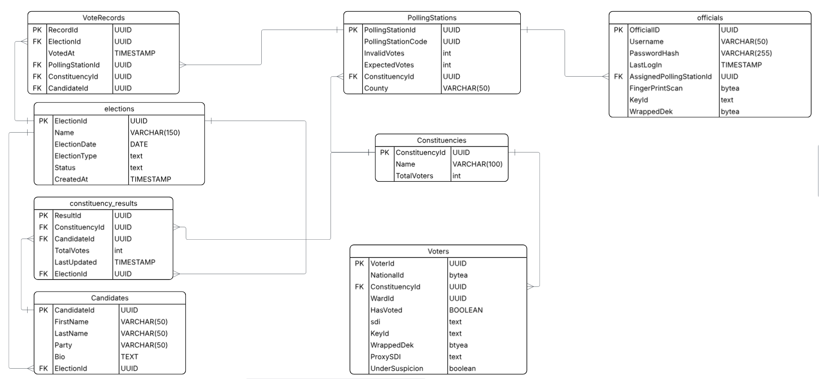
Figure 4. Entity Relationship Diagram showing structure and connections of tables in the systems database.

4.2.4 Hosting Environment
Amazon Web Services (AWS) was selected as the hosting platform due to its maturity, reliability, and strong security infrastructure. The use of AWS Learner Lab provided access to core services within the constraints of the project.
Two separate EC2 instances were deployed, one for the backend server and one for the PostgreSQL database. This separation ensures the database is not directly exposed to the public internet, as the server instance’s elastic IP is the only entity permitted to communicate with it, enforced through security group rules [53]. This approach significantly reduces the system’s attack surface.
Elastic IP addresses are assigned to both instances to ensure consistent addressing, which is required for DNS mapping using nip.io [36].
Sensitive configuration values, including database credentials and encryption keys, are stored using AWS Secrets Manager. Access to these secrets is restricted through IAM permissions, ensuring that only the server instance can retrieve them [53].

4.2.5 Biometric Hardware and Matching
The fingerprint scanner used in the project is a Columbo USB capacitive fingerprint scanner. Capacitive sensors measure electrical properties of the fingertip, making them more resistant to spoofing compared to optical alternatives [11].
Due to hardware limitations, the device outputs images in PNG format rather than standard biometric templates modern scanners produce. This influenced the design of the biometric processing pipeline.
SourceAFIS (AFIS) was chosen as the fingerprint matching library for this system. It is implemented in C# making it a native fit within the existing .NET ecosystem. It was also chosen for its ability to compare PNG templates due to the Columbo’s restrictions. AFIS accepts fingerprint images directly as input, meaning no format conversion was required [51]. AFIS operates on extracted minutiae points rather than raw images, comparing ridge endings and bifurcations between a probe template and a candidate template to produce a similarity score [51]. This approach is well established in identity verification and is significantly more robust to image variation than pixel level comparison [16]. Academic evaluation of AFIS on the FVC 2006 benchmark database achieved an Equal Error Rate (EER) of 0.379%, demonstrating strong matching precision under controlled conditions [52]. The library supports both one-to-one verification and one-to-many search, both of which are required by this system. Being open source was a practical advantage within the budget constraints of the project, though the primary justification for its selection remains its low equal error rate, its .NET native implementation, and its transparent, auditable algorithm design [5].
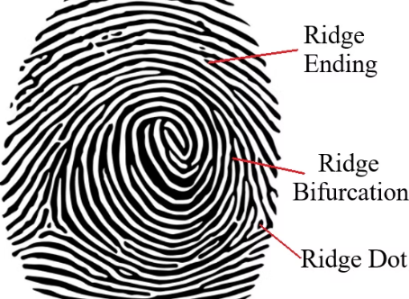
Figure 5. Diagram illustrating features of fingerprints [55].
The researcher selected the thumb as the primary biometric input. This decision was informed by both practical and technical considerations. The thumb typically provides a larger surface area compared to other fingers, resulting in a higher number of detectable minutiae points during capture [56]. This improves matching accuracy and reduces the likelihood of failed authentication attempts.

4.3 Integration and Accessibility
Drawing on the insights from the Brazilian system, the proposed e-voting system would initially operate alongside the traditional paper-based method. Unlike the Brazilian approach, the intention would be to introduce the biometric e-voting system immediately on an optional basis. This gradual, voluntary adoption would expose a significant portion of the electorate to the technology over time, helping to cultivate the public trust that this project seeks to establish. Importantly, this phased rollout would also generate substantial real world usage data, revealing unforeseen usability challenges as well as areas in which the system performs particularly well. Once sufficiently tested and refined through this process, the system would be well positioned to transition into the primary voting method across the UK.
In its current form however, the system has notable accessibility limitations. As it stands, the design is tailored specifically for use within a polling station, which presents a significant challenge given the proposal to replace the postal vote. Removing this option would disadvantage voters with limited mobility who depend on it and are unable to attend a polling station in person. Addressing this shortcoming will require further development. Potential solutions include the creation of a dedicated application that would allow an authorised official to oversee and facilitate voting outside of a polling station, or alternatively, the migration of the system to an online platform using biometric authentication through approved scanners integrated into a voter's personal device. Another potential method would be to assess eligibility for postal voting, make it only necessary for people unable to make it to a polling station.

5. Legal, Social, Ethical, and Professional Issues
This section focuses on the implications of developing and deploying a biometric e-voting system, examined across four key areas: legal compliance, social impact, ethical responsibility, and professional conduct. Each area was considered throughout the development process with the aim of ensuring the system considers a wider range of problems.

5.1 Legal
The most significant legal framework this system has to follow is the UK General Data Protection Regulation (UK GDPR) and the Data Protection Act 2018. Processing of biometric data under these regulations used for the purpose of uniquely identifying a person is classified as special category data, requiring the highest standard of legal protection and explicit justification for its processing.
To comply with this standard of protection, the researcher implemented a range of technical safeguards, including AES-256-GCM encryption of voter data at rest, envelope encryption during transmission, and strict data minimisation principles. The system stores only the information necessary for identity verification, reducing legal exposure associated with unnecessary data retention. Key management practices, including the use of AWS Secrets Manager and Key Management Service, further ensure that encryption keys are handled in accordance with best practice guidance on securing special category data.

5.2 Social
The introduction of biometric authentication has the potential to discriminate certain groups within the electorate, particularly elderly voters or those in manual occupations, where fingerprint quality degrades naturally over time. This limitation could be solved with a phased, voluntary rollout of the system alongside the existing paper-based method, thereby ensuring no voter is immediately excluded from participation. The potential removal of the postal vote also presents a social concern for voters with limited mobility, a challenge identified as requiring further development before the system could be considered a complete replacement.

5.3 Ethical
Biometric traits are permanent and cannot be altered in the event of a data breach, meaning any compromise carries irreversible consequences for individuals. The researcher addressed this through decentralised storage design, per-voter encryption, and ensuring biometric templates are only decrypted temporarily within server memory during comparison. The risk of function creep, whereby biometric data collected for voting could be repurposed for surveillance or law enforcement, was also considered. The system's architecture deliberately limits the scope of data use, and the conclusion made highlighted the need for strong legal safeguards to accompany any real world deployment.

5.4 Professional
Throughout the project, the researcher conducted development in alignment with professional standards expected of a computing scientist. This included grounding design decisions in academic literature, acknowledging the limitations of the system honestly, and following established security practices rather than implementing novel, untested solutions. The researcher also engaged in structured supervisor meetings and maintained a documented development process, reflecting a professional approach to project management and accountability.

6. Implementation and Testing

6.1 Database Implementation
Following the project plan, database implementation was prioritised as it provides the foundational layer upon which the rest of the system is built. As outlined in the design phase, the database was developed with voter anonymity and data confidentiality as primary concerns.
The Voter table is the most security critical component of the schema. All fields containing Personally Identifiable information (PII) are stored as bytea[], mapping directly to PostgreSQL’s bytea type. This decision was necessary because AES-256-GCM encryption produces raw binary ciphertext, and bytea ensures this data is stored without loss or transformation.
Each voter’s data is encrypted using a unique Data Encryption Key (DEK). This DEK is then encrypted (wrapped) using RSA-OAEP with the server’s public key and stored alongside the ciphertext as WrappedDEK. This envelope encryption pattern ensures that, even in the event of database exfiltration, no voter data can be decrypted without access to the server’s RSA private key. This private key is securely stored in AWS Secrets Manager and is only accessible by a designated instance within the Learner Lab environment.

One of the primary challenges encountered was achieving efficient voter validation. Performing a full scan of encrypted biometric data (e.g. fingerprints) would be computationally expensive and impractical on a large scale. To address this, the system implements Searchable Deterministic Indexing (SDI). The SDI is derived from a normalised combination of First Name, Last Name, Date of Birth, Postcode, and Town of Birth. This combination was selected due to its extremely low probability of collision, making duplicate identities highly unlikely. There is an unusual case involving twins who share identical identifying details, including name, date of birth, postcode, and town of birth, which presents a distinct challenge for the validation process. The approach used to resolve this issue is outlined later in this section.
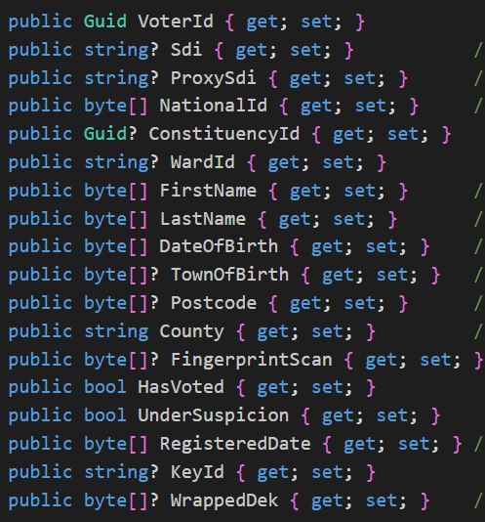
Figure 6. Voter table including demonstration data.

The SDI is hashed using an HMAC with a secret key known only to the server. This ensures that, even if an attacker possesses the original input data, reproducing the hashed SDI without the key is computationally infeasible. The SDI field is explicitly indexed, enabling efficient lookup during authentication without requiring decryption of any sensitive data.
To support proxy voting, a ProxySDI field is included in the Voter table. This allows a proxy voter record to be securely associated with a primary voter, in accordance with current proxy voting regulations.
It should be noted that First Name, Last Name, and Date of Birth are also stored as encrypted ciphertext in the current implementation. This is included solely for demonstration purposes during assessment and is not required for system functionality.
Ballot anonymity is enforced structurally within the VoteRecord table, which contains no reference to the Voter table. Instead, it only links to election-related entities such as CandidateID, ConstituencyID, and PollingStationID. As a result, even with full database access, it is not possible to associate a cast ballot with a specific voter.
Voter participation is tracked using a HasVoted boolean field in the Voter table. This field is updated within the same Entity Framework Core transaction as the insertion of a corresponding VoteRecord, ensuring anonymity and preventing race conditions.
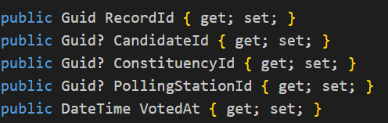
Figure 7. VoteRecord table.

6.2 HTTPS Configuration and Transport Security
At an early point in the server’s development, a deployment challenge emerged due to issues with implementing HTTPS. HTTPS requires a valid hostname for issuing a certificate via Let’s Encrypt, but the EC2 instance doesn’t have one, it only has an elastic IP address. To resolve this problem, nip.io was used. Nip.io is a wildcard DNS service that maps hostnames containing an embedded IP address back to that IP. The Elastic IP (34.238.14.248) is mapped to the hostname 34-238-14-248.nip.io, which is provided by nip.io. This service automatically resolves subdomains containing an IP address to that IP, meaning 34-238-14-248.nip.io resolves to 34.238.14.248 without requiring manual DNS configuration. This provides a publicly resolvable Fully Qualified Domain Name (FQDN), which was then used by Let’s Encrypt to provide a TLS certificate, allowing HTTPS communication.
TLS termination is handled entirely by Nginx reverse proxy which runs on the same EC2 instance the server does. Nginx listens on port 443, performs the TLS handshake and forwards decrypted requests over HTTP to Kestrel on localhost: 5000. The kestrel binding is restricted to the loopback interface which means the application is not able to be contacted from the internet, all traffic must pass through Nginx.
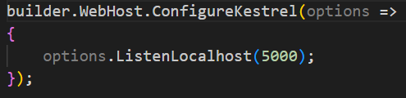
Figure 8. Kestrel local port binding for Nginx reverse proxy.

6.3.1 API Endpoint Structure
The server is built using ASP.NET Core's minimal API pattern, where each route is registered as a lambda directly in Program.cs rather than through controller classes. This keeps endpoint logic explicit and co-located, which was well suited to a project of this scale. The endpoints are organised into three logical route groups: /auth/ for session management, /api/official/ for Official App operations, and /api/voter/ for Secure Vote App operations. An /api/crypto/ endpoint exposes the server's RSA public key to clients on request, and /hubs/voting hosts the SignalR real-time hub.
Access control is enforced uniformly through JWT role based authorisation. Every sensitive endpoint is decorated with a RequireAuthorisation policy limiting access to either the official or voter role. Roles are embedded in the token at the point of login and validated on every subsequent request. Sensitive contextual information such as polling station, county, and constituency is never read from the client request body, it is derived exclusively from the JWT claims. This ensures that an authenticated official cannot query another station's data by modifying a request parameter.
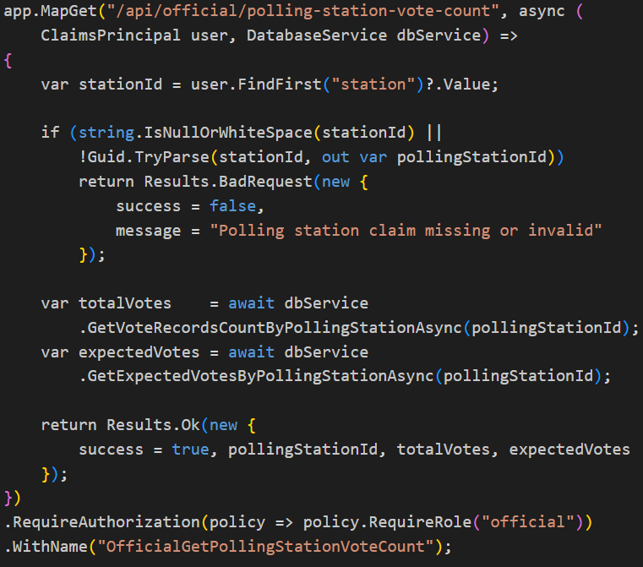
Figure 9. Polling stations vote count API end point.
As demonstrated in Figure 9, the polling station identity is extracted from the ClaimsPrincipal object on line 3. The endpoint validates that the claim is present and well-formed before proceeding, returning a structured error response if not. Two asynchronous database calls then retrieve the total votes cast and the expected turnout for that station, which feeds the live dashboard in the Official App. This pattern of claim derived context is applied consistently across all protected endpoints in the system.

6.3.2 JWT Token Distribution
To limit access to both the voter and official apps, access to API endpoints the assignment of JSON Web Tokens (JWT) was used. The JWT token is used as an identity that API endpoints can verify, making sure that a request is not coming from a wrong app or an outside attacker. The signing secret for the JWT is not stored in configuration files nor environment variables but is retrieved at startup from AWS secrets manager under the jwt-secret and cached in memory for the lifetime of the process. The SecretsHelper enforces a minimum length of 32 bytes on the retrieved secret, failing fast if the value is absent or short. This prevents the server from starting in a misconfigured state.
The validation parameters are configured with zero tolerance. ClockSkew is set to TimeSpan.Zero, meaning a token that has expired by even a second is rejected, allowing for no accidental permission granting nor an attack using a time gap to exploit permissions. The Issuer and audience are both validated, so tokens issued by any other authority or intended for any other consumer are refused.
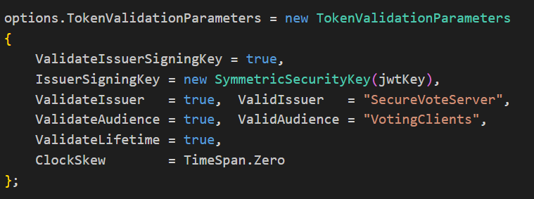
Figure 10. JWT token validation parameters.
Tokens carry a rich claim payload beyond the standard subject and role fields. At official login, claims for polling station, county, constituency, systemCode and a monotonically incrementing tokenId are embedded. These claims are then read server side on every protected request. StationId is never trusted from the request body, only from the JWT. Tokens also expire after eight hours, which aligns with the voting period and prevents any requests from being submitted once official voting hours have ended. The JWT tokens county and constituency claims are used in the navigation of the channels in the server, defined by database records these cannot be changed by the user. This maintains a strict assigned channel use and allows for predictable use of the channels.

6.3.3.1 Organisation of channels
Britain has 650 constituencies, each with a varying number of voters and multiple polling stations per constituency. In an electronic voting system, each polling station creates a new server connection, and without proper organisation, communication between voter devices and the Official App could become slow and disorderly. The following implementation was designed to address this directly.

The initial approach used HTTP polling, whereby the Official App made repeated timed requests to the server to check for new events such as a voter casting a ballot. In practice this proved problematic. Response latency was noticeable even at short polling intervals, and the server was fielding a constant stream of requests regardless of whether any activity had occurred. The deciding factor against this approach was the delay in delivering voter device status updates, a feature used to notify the Official App when a connected device was experiencing a problem or when there was suspicion of electoral fraud. Late delivery of these updates carried a direct security cost. The polling approach was replaced entirely with SignalR, which maintains a persistent WebSocket connection and allows the server to push events to clients the moment they occur. This decision was made midway through the app development in March and required considerable time to correct.
The channel structure is organised first by county and then by constituency. All stateful in memory dictionaries follow the same nested pattern, keyed by county, then constituency, then connection. Vote notifications, device statuses, device commands, and voter access codes are all structured this way using thread safe ConcurrentDictionary collections, ensuring no official ever receives events intended for another constituency.
On connection to the VotingHub, every client is assigned to a set of named SignalR groups derived directly from their JWT claims, as shown in Figure 11.
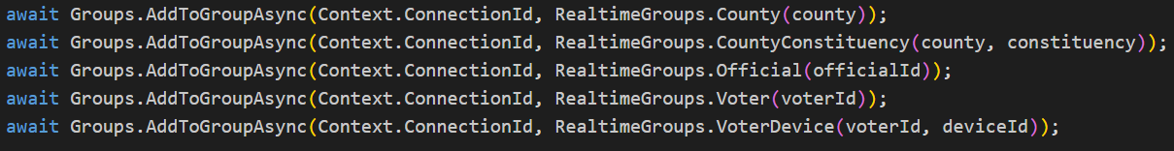
Figure 11. SignalR group assignments made on client connection to VotingHub.
Group names are generated by the RealTimeGroups static class, producing deterministic keys such as County:Kent:Constituency:Ashford. A vote cast in Ashford is pushed only to the official:{officialId} group of the linked official rather than being broadcast county wide. Device lock commands target voter:{voterId}:device:{deviceId} directly. If county or constituency claims are absent from the token, the connection is aborted server side, preventing any misconfigured client from entering the channel hierarchy.

6.3.3.2 Load Testing
To evaluate the scalability of the SignalR hub, a concurrent connection load test was conducted against the live EC2 hosted server. The test established connections in ramped levels of 100, 250, 500, 1,000, and 2,000, with each level held open for 30 seconds before disconnection. All connections authenticated via JWT and connected through the production Nginx reverse proxy over HTTPS using the Long Polling transport. The server handled the first three levels without any failures, sustaining 100, 250, and 500 simultaneous connections with average connect times of approximately 880–925 ms. At 1,000 connections, 964 succeeded with 36 failures, indicating the server was approaching its practical concurrency limit under the current EC2 instance configuration. At 2,000 connections, only 989 succeeded, with 1,011 failing, suggesting that resource exhaustion becomes a significant factor beyond 1,000 concurrent connections. Notably, average connect times remained stable across all levels at around 900 ms, indicating that latency degradation was not the bottleneck.

6.3.4 SourceAFIS Fingerprint Matching Algorithm
SourceAFIS 3.14.0 is the fingerprint matching library integrated into the server. It uses a minutiae based approach, converting a raw fingerprint image into a template through image processing and feature extraction, encoding ridge endings and bifurcations as discrete points. Two templates are then compared using a matcher that evaluates the spatial relationships between minutiae points, returning a floating point similarity score. This score is compared against a predefined threshold to determine whether a match has occurred, as illustrated in Figure 12.
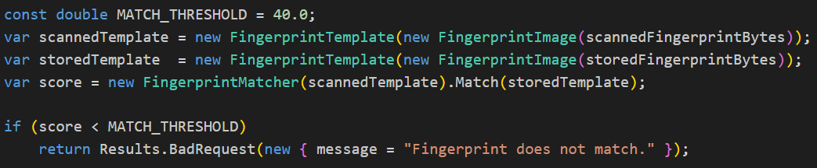Figure 12. Fingerprint matching pipeline from the server.
Both probe and candidate images are accepted as raw PNG byte arrays, which was a key factor in selecting SourceAFIS given the hardware constraints of the Columbo scanner. The matching threshold was set to 40.0, a value verified against two open source fingerprint datasets, each testing a distinct aspect of the algorithm's performance.
To validate the chosen threshold, a dedicated test program was developed. The program references SourceAFIS 3.14.0, the same version used by the server, and uses the same operating threshold of 40.0. For each dataset, the program loads all fingerprint images and constructs the full set of genuine pairs (same finger, different scan) and impostor pairs (different fingers). Each pair is scored using SourceAFIS. A 500-step threshold sweep is then applied across the full score range to find the Equal Error Rate (EER), which is the threshold at which the False Acceptance Rate (FAR) and False Rejection Rate (FRR) are closest. The results of each test run were written to a CSV file, found in Appendices H and I.
Metric | FVC2002 | SOCOFing
Equal Error Rate (EER) | 5.11% | 36.66%
FAR at threshold 40 | 0.00% | 0.00%
FRR at threshold 40 | 18.21% | 94.64%
Table 3. Performance table of SourceAFIS on Different Datasets.
As shown in Table 3, FVC2002 consists of repeated scans of the same fingers captured on real hardware and provides the primary performance benchmark for the system [61]. The 5.11% Equal Error Rate sits within SourceAFIS's published range for that dataset, and the large separation between genuine and impostor score averages confirms strong discrimination under normal scan variation. At the chosen threshold of 40.0, the FAR is 0%, which is the critical security property for a voting system where no unauthorised individual should be able to authenticate as another voter. The False Rejection Rate of 18.21% indicates that approximately one in five legitimate authentication attempts would require a retry, which is mitigated in the system by the three attempt policy and the accessible fallback mechanism described in the specification.
SOCOFing tests a different scenario. Its altered images simulate physical attack on the fingerprint itself, with cuts and deliberate damage applied to a significant proportion of subjects [60]. This degradation causes the EER to rise sharply to 36.66%, illustrating that severely mutilated fingerprints become increasingly indistinguishable from impostor samples. The practical implication for this system is that its security relies on the integrity of the enrolled fingerprint template. A voter whose fingerprint sustained significant damage between enrolment and polling day would likely face repeated authentication failures.

6.3.5 The Twin Dilemma
The Searchable Deterministic Index (SDI) is an HMAC-SHA-256 hash of a normalised string derived from five fields: first name, last name, date of birth, postcode, and town of birth. By design, two individuals who share all five values will produce an identical SDI and therefore insert into the database with the same SDI. In practice this edge case is most likely to occur with twins sharing the same surname and address. When a lookup returns more than one candidate record, the server sets RequiresDisambiguation to true in the response and returns the list of candidate voter IDs to the client. The client presents the voter with a fingerprint scan prompt as usual, then resubmits the authentication request with CandiateVoterIds populated.
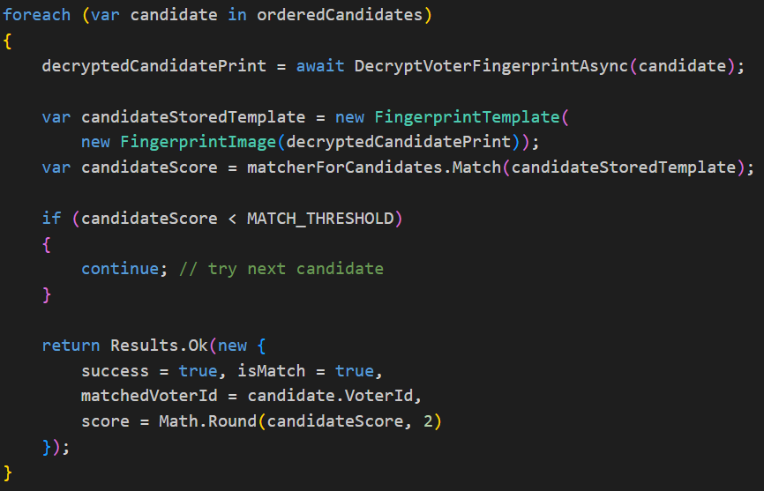
Figure 13. SDI collision disambiguation loop.
As shown in Figure 13, the server iterates through each candidate in order, decrypting and scoring their stored fingerprint template against the live scan. The first candidate whose similarity score meets or exceeds the match threshold is identified as the authenticated voter, and the flow continues identically to the standard authentication path. If the matched candidate has already voted, a rejection response is returned, and the voter is prompted to alert an official. Simultaneously, the Official App is notified of the repeated attempt, the voter device is locked, and a status changed for the device, alerting the official to potential electoral fraud.
This approach resolves the twin edge case and additionally handles the statistically negligible probability of a natural SDI collision, without exposing the identity of other candidates to the client at any point. All decryption and comparison operations are performed exclusively on the server, ensuring that sensitive voter data never leaves the server boundary during disambiguation.
An operational challenge also remains, requiring a duplicate fingerprint scan across all registered voters in the two weeks leading up to polling day. This check ensures that no two voters share a stored biometric template, which is a prerequisite for the disambiguation algorithm to function correctly. If a duplicate fingerprint were present, there would be a risk that an impostor's record could appear first in the candidate list and be authenticated against an identity that does not belong to them, allowing a fraudulent vote to be case in another voter’s name. This duplicate detection feature is implemented within the Official App and must be completed before the system can be considered operationally secure.

6.3.5.1 SDI Hash Verification Test
To verify the correctness of the Secure Digital Identity function, a determinism test was added to the server startup sequence. The test calls ComputeSdiHmacSha256 twice with identical inputs and once with the reversed string. Two properties were asserted. First that identical inputs always produce the same hash and second that a single character change in the input produces a completely different hash. The code for the test is shown in Figure 14 and the console output confirming both assertions passed is shown in Figure 15. These two properties are essential to the correctness of the system as determinism of the SDI is essential for finding records of a voter.
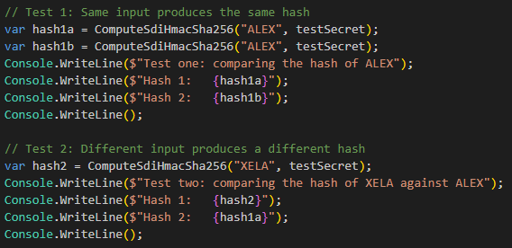
Figure 14. SDI hash determinism test code.
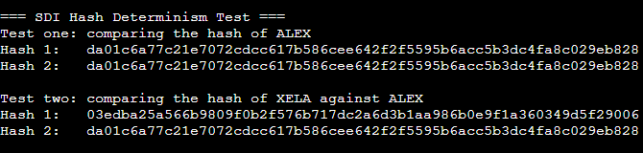
Figure 15. SDI hash determinism test output.

6.3.6 Duplicate Fingerprint Detection
To address the duplicate fingerprint risk, a full pairwise comparison algorithm was implemented within the server. When an official requests this operation, the server fetches every registered fingerprint and decrypts each one in turn. It then constructs a list of voter and fingerprint template pairs using two parallel arrays of equal length. This structure allows matched fingerprints to be grouped efficiently as comparisons are made.
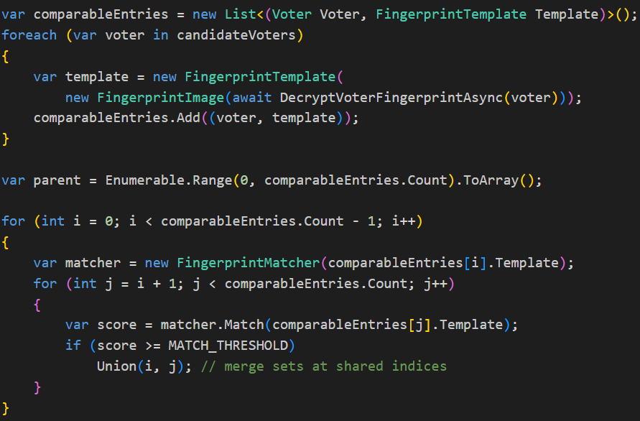
Figure 16. Duplicate fingerprint detection algorithm.
Every template is compared against every other using SourceAFIS. When a duplicate is detected, the corresponding voters are grouped together and the UnderSuspicion field for all affected records is set to true within the database. Once all comparisons are complete, the groups of suspected duplicates are returned to the Official App. The information returned includes the names and National Insurance numbers of the flagged voters, allowing the official to investigate and resolve each case before polling day.
The algorithm operates at a time complexity of O(n²), where n is the number of registered voters. This is a recognised limitation of the current implementation. For a national deployment involving millions of registered voters, further development of this algorithm would be necessary.

6.4 Official Application

6.4.1 Avalonia and MVVM Architecture
The official application is a desktop system built using Avalonia UI, a cross platform .NET framework, and follows the Model View ViewModel (MVVM) architectural pattern implemented via the CommunityToolkit.Mvvm library. Neither Avalonia nor MVVM had been used by the researcher prior to this project. The selection was based on Avalonia’s suitability for cross platform desktop development in C#, and MVVM’s ability to clearly separate user interface concerns from business logic. Each screen consists of a View, responsible for the UI, and a corresponding ViewModel, which handles the underlying logic.

6.4.2 Redesign of Official Application
The polling station management screen is the primary interface used by election staff during live voting. Its purpose is to display all connected voter devices in real time, along with their current status, and to allow staff to remotely lock or unlock devices if suspicious activity is detected. Alongside the device list, a panel presents live vote counts, turnout percentages, and overall system state retrieved from the server. This screen received the most critical feedback during user surveys, with comments indicating that it was confusing and cluttered (Appendix G).
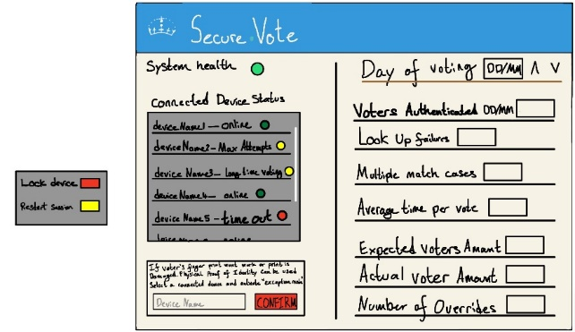
Figure 17. High fidelity of polling station management screen.
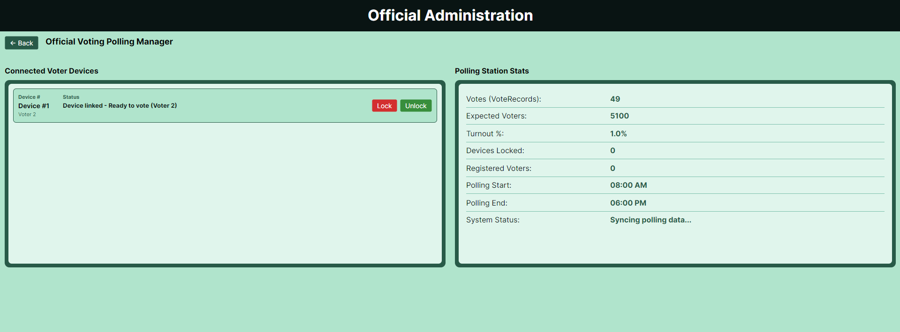
Figure 18. Final version of polling station management screen.
The initial design, shown in Figure 17, was produced as a wireframe prior to implementation. Survey feedback highlighted several usability issues. The interface lacked contextual guidance, making it difficult for new users to understand functionality or interact with features. For example, there was no clear method for locking or unlocking a device.
The final design, shown in Figure 18, incorporates feedback from both surveys. The layout was simplified into two distinct sections with connected devices on the left and polling station statistics on the right. The device interface was redesigned, replacing the previous colour based health indicators with clearly labelled status text. Additionally, explicit lock and unlock buttons were added to each device template, making these controls immediately visible and accessible.

6.4.3 Device Status and Locking
Each voter device connects to the server via SignalR and joins a group scoped to the voter's identity. When the connection is established or its status changes the server pushes a presence event to the official's client. This was not always the mechanism used; the original implementation relied on HTTP polling where the official app requested device statuses on a fixed interval. When tested, the intervals created a gap between status updates of up to 20–30 seconds, which was unacceptable for a lock command when an official needed immediate action against an attacker. The migration to SignalR reduced this to near instant delivery and was the primary driver for adopting the persistent connection architecture.
The lock command itself follows a three step flow, the officials viewmodel sends a lock_device command to the server via the API, the server then forwards it through signalR directly to the target device’s group. Then the devices status is reflected back to all subscribers including the official’s screen. The viewmodel then updates the device status to locked before any confirmation is sent.
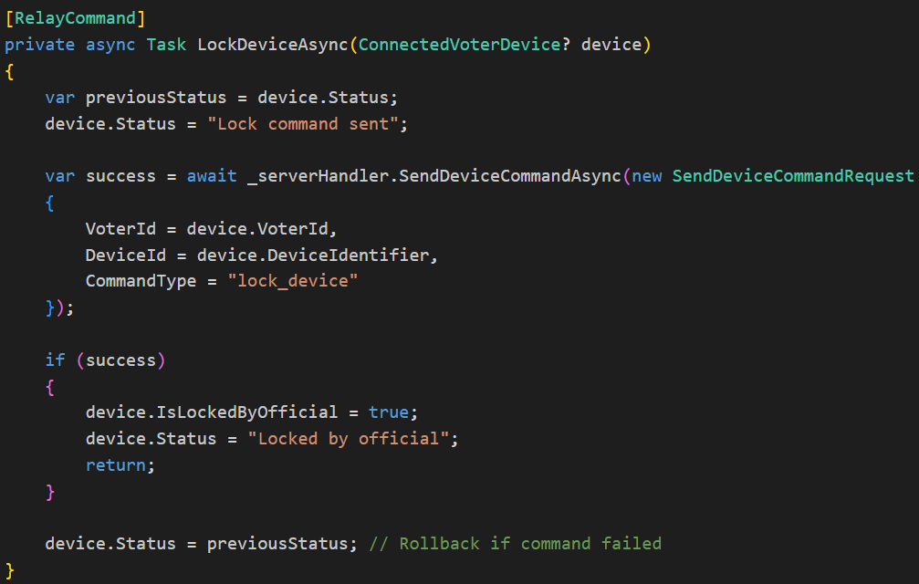
Figure 19. Device lock command handler.
If the command to lock fails the status rolls back to its previous value on the official’s screen, this is so the official is not misled into thinking that the device is secured. When the lock is sent successfully the voter device receives it via its own SignalR subscription and disables the voter interface, preventing further interaction until the unlock command is sent.

6.5 Secure Vote App

6.5.1 Design Choices
The authentication screen underwent the most significant design changes during development. During user testing, participants consistently reached for the scanner immediately upon arriving at the screen, without realising they first needed to press a 'Start Scan' button to activate it. This occurred every time a new participant used the system and showed a fundamental mismatch between user expectation and interface behaviour, requiring a redesign of how the scanner was activated.
The redesign resolved this by making the scanner activate automatically as soon as the authentication screen is opened. The scanner runs continuously until a finger is detected and the capture quality is sufficient, removing the need for any manual initiation. If authentication fails, the scanner deactivates for five seconds before restarting automatically, giving the voter time to reposition their finger for a better placement. This cycle repeats up to three attempts before the session is ended. The cooldown period also serves a secondary purpose, preventing rapid repeated scan attempts that could be used as a brute force attack.
A live fingerprint preview was also added to the screen, displaying the image being captured in real time. This gives the voter a visual of scan quality, allowing them to adjust their finger position before the capture completes rather than only discovering a poor scan after a failed authentication attempt.

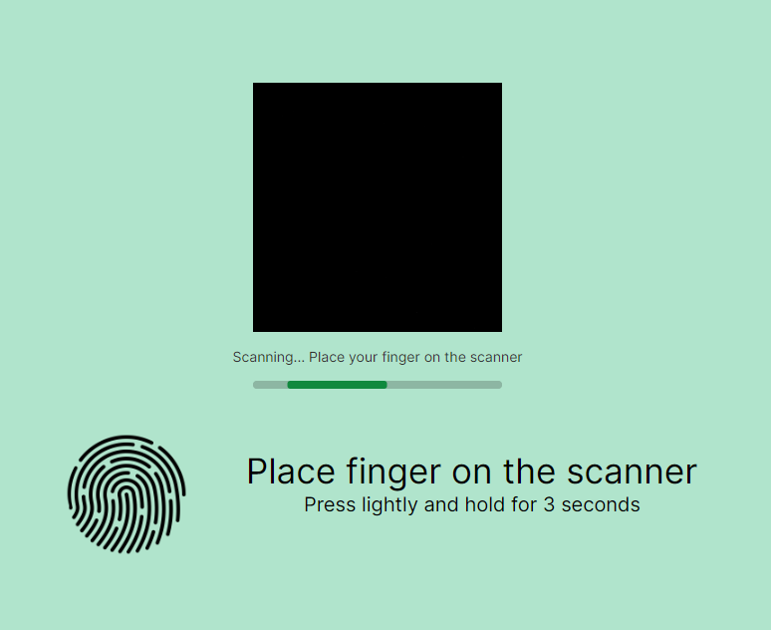
Figure 20. Fingerprint scanning view.

6.5.2 Scanner Integration
Integrating the IBScanUltimate Columbo scanner was one of the most time-consuming challenges in the project. The researcher had no prior experience integrating hardware into a software project, making each stage a learning experience that slowed development. The first step was contacting the SDK provider directly by email to obtain the development kit, after which a P/Invoke wrapper had to be written to allow the .NET applications to communicate with the scanner.
Once the scanner was connected the application still did not function correctly, producing an error indicating that a template could not be captured. Significant time was spent debugging the wrapper code looking for mistakes. The underlying problem was unrelated to the code itself. The SDK had been set to request a higher-grade template than the Columbo hardware could generate, resulting in the device silently returning no data despite accepting the request. Adjusting the image type to the basic capture resolved the issue without further complications. A further limitation of the IBScan SDK is that it only provides drivers for Windows, Linux and Android, meaning the scanner integration is not functional on macOS despite both applications otherwise running cross-platform via Avalonia. This constrains the current deployment to Windows devices only if users wish to progress past authentication.
A second compatibility problem appeared between what the scanner produces and what SourceAFIS accepts. The SDK delivers a raw 8 bit grayscale pixel buffer with metadata attached. A conversion step was needed so that every scan returns a PNG.
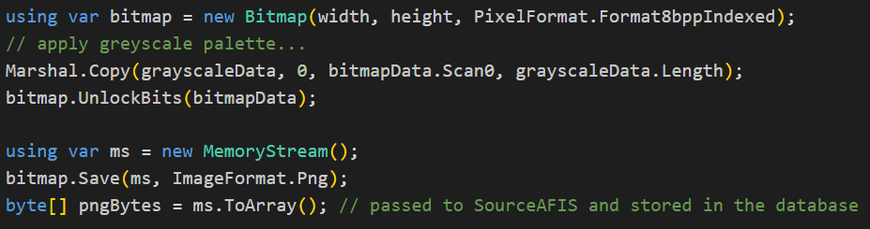
Figure 21. Fingerprint image preprocessing pipeline.
This conversion runs at both registration and authentication, ensuring the stored and live fingerprint images are always in the same format.

6.6 AWS

6.6.1 AWS Hosting
AWS was chosen as the hosting platform as it is the industry standard and provided the infrastructure needed to run the system as it was designed to operate. This was the researcher's first time deploying to a cloud environment. Two EC2 Linux instances were created, one running the ASP.NET Core server behind an Nginx reverse proxy, and a second hosting the PostgreSQL database. Elastic IPs were assigned to both instances to provide stable addresses that persist across restarts. Security groups were configured to restrict inbound traffic to only the necessary ports ensuring the instances were not unnecessarily exposed.

6.6.2 AWS Security
All sensitive cryptographic material in the system is stored in AWS Secrets Manager rather than in configuration files or environment variables, which would risk exposure through source control or filesystem access. Three secrets are managed this way, the JWT signing secret, the SDI HMAC key and the RSA key pair used for envelope encryption. All three are fetched and cached in memory at server startup via Secrets Helper, so there is no per request latency from secret retrieval. A key pair validation step also runs at startup, the server derives the public key from the loaded private key, computes a SHA-256 fingerprint of both the derived public key and the separately stored public key, and compares them. If they do not match, a warning is logged before the server continues, catching any misconfiguration before it causes silent authentication failures at runtime.

6.7 Artificial Intelligence
During implementation, Artificial Intelligence tools were used to accelerate development and support the learning of unfamiliar technologies, including Avalonia, SignalR, and ASP.NET Core [62]. AI helped to reduce time spent on low level integration code, allowing development momentum to be maintained and new frameworks to be understood more quickly. In all cases, AI-generated output was reviewed, tested, and adapted by the researcher before being incorporated into the system7.

7. Evaluation

7.1 User Evaluation Methodology
To evaluate the system, two surveys were conducted at different stages of development. The first was conducted on the high-fidelity mock-ups (Appendix A) to gather feedback on the interface design. The second was conducted after the redesign that resulted from the first survey's feedback. Both surveys used the same questionnaire (Appendix J), consisting of five point ratings and open-ended text responses. Participants were briefed on the anonymous nature of the data collection process and were given a consent form to review and sign (Appendix L). The full results of both surveys are available in Appendix G.

7.2.1 Survey One
The first survey identified significant usability issues with the Official Polling Manager screen. When participants were asked to rate the difficulty of Task 4 (see Appendix J), which focuses on use of the Polling Manager screen, 64% of responses rated it as very difficult. The most common open-ended response cited the layout as unintuitive or overly complex. One participant noted that they would not have known device locking was possible had the task not specified it. These comments directly affected the redesign. Participants reported that the voter app was intuitive and that the overall flow was clear.

7.2.2 Survey Two
Following the redesign, the same questionnaire was repeated on the live system. The second survey shifted focus away from the Polling Manager screen, with responses raising new issues primarily around the user interface and fingerprint scanning. Feedback on the Official App indicated that the process of linking a voter device was unclear, and that an average user would be unlikely to complete this step without assistance. Across both apps, the most commonly cited difficulty was the requirement to press a start scan button to initiate fingerprint capture. Several participants left the open-ended difficulty questions blank, suggesting the redesign had successfully addressed the core usability concerns raised in the first survey.

7.2.3 Analysis of Survey Results
Whilst the surveys aided in improving the design of both applications, the sample size of eleven participants limits the ability to generalise the results. All participants possessed some level of computing knowledge, which excludes users who may struggle with technology and who are likely to represent a portion of both polling station staff and voters in real-world settings. The results suggest that a structured demonstration or training session would significantly improve an official's ability to operate the system, particularly for the device linking process which requires prior knowledge of the workflow. To properly evaluate the system, election officials would need to be involved in user testing to identify the real skill gap and inform any necessary training materials.

7.3 Methodology Evaluation
The agile development methodology adopted for this project proved broadly effective. Building the system layer by layer, starting with the database and progressing through the server and client applications, meant that each stage built on a stable foundation. Security decisions made early, such as envelope encryption and JWT configuration, did not need to be revisited as the system grew.
A strength of the agile methodology was demonstrated when the system was switched from HTTP polling to a persistent SignalR connection. The need for this change was identified during development of the client applications, outside the server's development sprints. The flexible nature of agile allowed this to be factored into the following sprint, enabling a fast response to a significant architectural problem without disrupting the broader development timeline.
The iterative approach also allowed user feedback from the first survey to directly inform implementation before the final system was built, which was one of its clearest practical benefits. Overall, the methodology suited an individual scale of this project, though a more structured sprint review process would have helped identify architectural risks like polling earlier.

7.4 Requirements Evaluation
The majority of the must-have functional requirements across all three components were met. Both the Official App and Secure Vote App successfully encrypt all data in transit, authenticate via fingerprint, link to one another through a hashed access code, and communicate with the server through structured API endpoints over a persistent SignalR connection. The server correctly separates vote records from voter identity, verifies fingerprints against stored templates using SourceAFIS, and distributes lock and unlock commands to the correct linked voter devices. The duplicate fingerprint detection requirement was implemented and returns grouped results to the official on request.
The device locking requirements were fully met. The voter device locks automatically after three failed authentication attempts, the Official App can manually lock and unlock any connected device, and the lock state is enforced across all screens of the voter app at all times. The three attempt limit, status messages to the official on failure, and confirmation of a successful vote submission were all implemented as specified.
Several of the system’s should-have requirements were also achieved. Proxy voting is supported, officials can log out and terminate their session, and JWT tokens expire after eight hours as specified. The Avalonia framework satisfies the cross-platform requirement, with both applications running on Windows and macOS.
Three requirements were only partially addressed. The server requirement to delete or anonymise biometric data after a defined retention period in line with UK GDPR was not implemented in the current version. The server audit log requirement was also not fully implemented as security relevant events such as failed authentications and lock commands are not logged except for a status update sent to the official management screen. The cross-platform requirement was also only partially met. Although both applications run on Windows and macOS via the Avalonia framework, the IBScan Columbo fingerprint scanner SDK only provides drivers for Windows, meaning fingerprint capture is not functional on macOS in the current deployment.
The non-functional requirement to support over 10,000 concurrent connections was not met. Load testing demonstrated that the server could reliably sustain just under 1,000 simultaneous connections, beyond which connection failures increased significantly (see Appendix K). This limitation is due to the constraints of the EC2 instance tier used for deployment rather than a fundamental flaw in the application architecture. A further performance consideration is the fingerprint duplicate detection algorithm, while functionally correct, its time complexity is O(n²), meaning it scales poorly as the voter database grows and would require before deployment at national scale.

8. Description of Final Product

8.1 System Overview
The final product is an Electronic Voting System that uses biometric authentication to verify a voter. The system consists of two desktop applications a cloud-hosted Server on AWS and a cloud-hosted database on AWS. The Official App is operated by polling station staff, and the SecureVote App is used by voters to cast their ballot. Both apps are built with Avalonia and run on Windows and macOS. The server runs as an ASP.NET Core API on an AWS EC2 instance, accessible to both applications over HTTPS via a persistent SignalR connection.

8.2 Major Areas of Functionality
Two key areas of functionality have been selected to demonstrate how the components interact: device linking and status updates. Together, these illustrate how the Official App and SecureVote App communicate through the server, and how actions taken by an official directly affect a connected voter device.

8.2.1 Device Linking Process
Before any ballot can be cast, the SecureVote App must be linked to the Official App. This is achieved through an access code generated by the official. As shown in Figure 22, the official enters a code of their choice through the access code generation view.
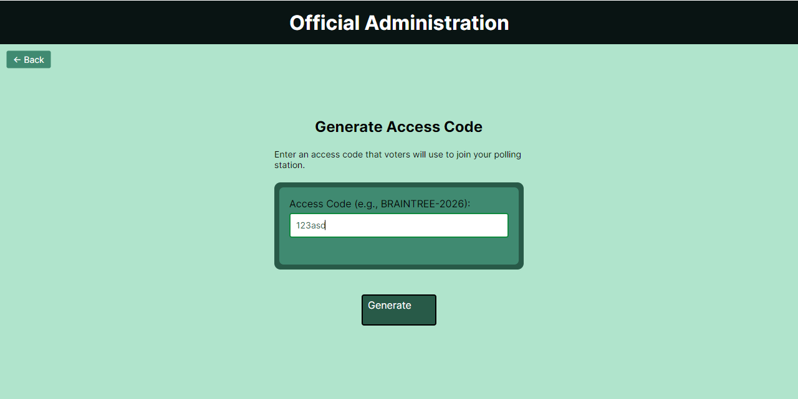
Figure 22. Generate access code view in official app.
When the generate button is pressed, the code is checked against the database. If an identical code already exists, the official is prompted to enter a different one. Once a unique code is confirmed, it is hashed and the corresponding polling station record is updated. The voter then launches the SecureVote App, which opens to the linking screen shown in Figure 23. The voter's county, constituency, and the code generated by the official must all be entered to establish the connection, ensuring that each device is tied to the correct polling station session.
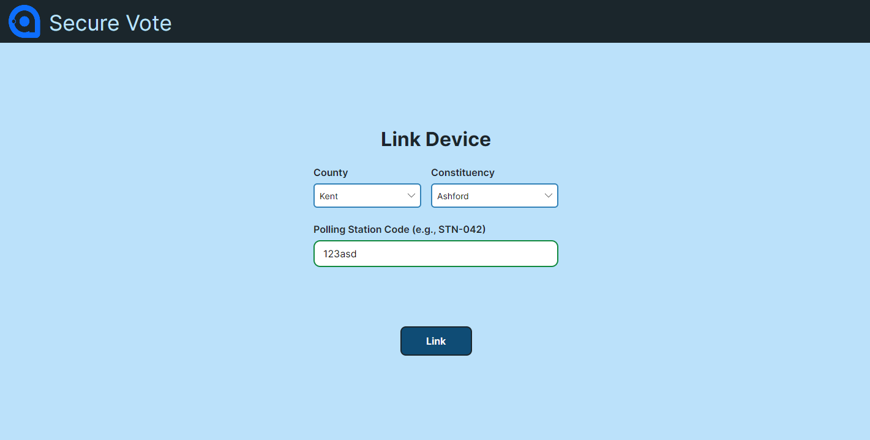
Figure 23. Voter app linking screen.
Figure 23 illustrates the initial linking screen displayed upon launching the SecureVote App. Establishing a connection requires the user to input the county, constituency, and the unique code generated in Figure 21.

8.2.2 Voter Device Status Update Mechanism
The second area of functionality demonstrates how the system responds to potential electoral fraud. If a voter attempts to cast a second ballot, the system identifies this as a duplicate submission. The voter's screen is immediately locked, as shown in Figure 24, preventing any further interaction with the system and stopping the fraudulent attempt.
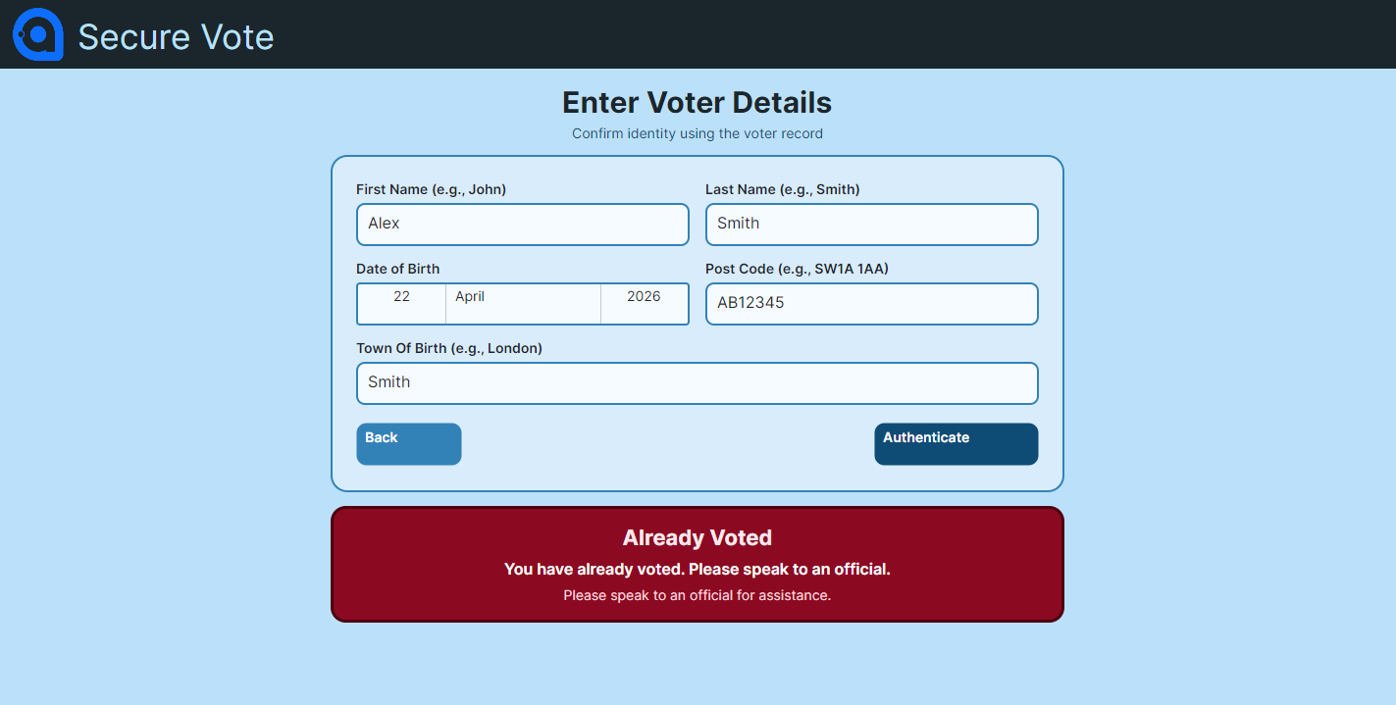
Figure 24. Enter voter information screen locked by second vote attempt.
Simultaneously, the Official App is updated with the device’s status, notifying the polling official of the suspicious behaviour. This enables an appropriate response, such as manually locking the device via the Polling Manager interface illustrated in Figure 25.
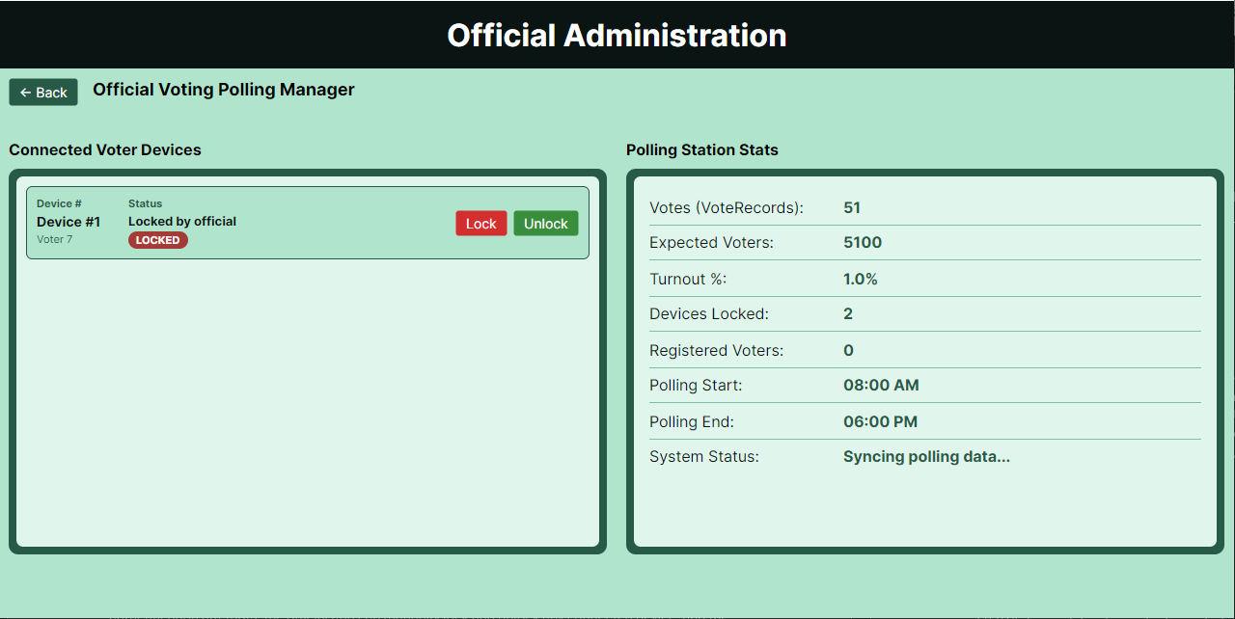
Figure 25. Official polling manager screen having locked a voting device
When the lock command is issued, it is sent from the Official App to the server, which forwards it directly to the target device via SignalR. The voter device is then redirected to the linking screen, as shown in Figure 26.
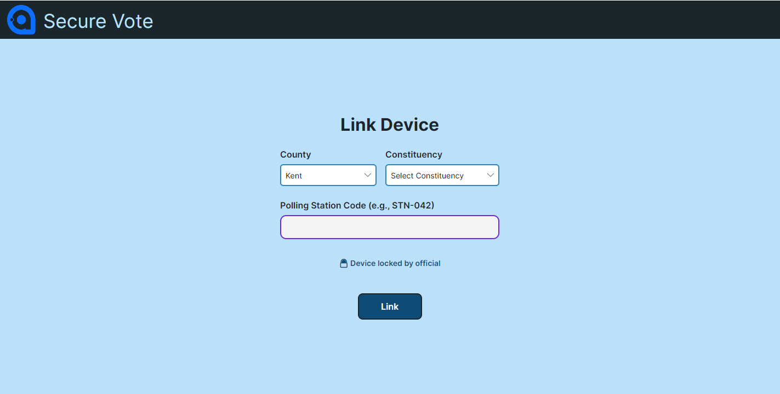
Figure 26. Voter device screen locked by official.
Once locked, the voter device is fully disabled. Although the JWT token and server connection remain valid, the voter cannot enter any information or submit a linking request, with any such attempt being rejected at the server. The official retains the ability to unlock the device remotely, which would allow the session to be re-established and voting to resume if appropriate.

9. Appraisal
When appraising the project, it was concluded that the development process had run relatively smoothly overall, and there was a high level of satisfaction with the final product and its functionality. In reflecting on what could be improved if the project were undertaken again, two key areas were identified: server design and the structure of user surveys.
The first area concerned server design. With no prior experience in building an ASP.NET server, the project encountered a steep learning curve in understanding the framework and its conventions. This inexperience contributed to the inappropriate selection of polling as the server’s communication structure, which significantly delayed implementation. In retrospect, incorporating an initial experimental phase into the project plan would have allowed time to test unfamiliar technologies before committing to architectural decisions.
The second area related to user surveys. Only two opportunities were allocated for collecting public feedback, which was sufficient for evaluating two stages of the user interface but did not allow for a final assessment of the completed system. A third survey would have provided valuable insight into how users interacted with the finished interface, offering a more comprehensive evaluation of its overall usability and effectiveness.

10. Summary and Conclusion
This project set out to develop a fingerprint authenticated electronic voting system capable of strengthening electoral integrity in the UK. Through the literature, several structural weaknesses were identified within the existing paper-based voting system, including susceptibility to voter impersonation, risks of ballot tampering, and delays associated with manual counting. On this basis, the purpose of the proposed system was defined in the aim (to verify voter identity through fingerprint authentication before a vote is cast, removing dependence on easily forged identifiers, whilst ensuring no vote can be linked back to the individual who cast it).
Following an examination of international precedents, fingerprint scanning was selected as the most suitable biometric modality, balancing cost effectiveness with a FAR below 0.1%. The system was built across three integrated components: the Official App, the SecureVote App, and a cloud-hosted server, protected by multi-layered encryption, TLS transport security, and structural ballot anonymity enforced at the database level.
Both rounds of user evaluation demonstrated that the system is functional and that the voting process itself is intuitive for users, with the Official App benefiting considerably from the redesign informed by participant feedback. It was concluded that the system demonstrates genuine viability as a foundation for biometric e-voting in the UK, with accessibility, scalability, and GDPR-compliant data retention identified as the most critical areas requiring further development before national deployment.

11. Recommendations for Future Work
The first recommendation is the addition of language options. Given the linguistic diversity of Britain's population, many users may not have English as their first language. Implementing a language selector would make the application significantly more inclusive and accessible to a wider audience.
The second recommendation concerns the fingerprint scanner. The current implementation only functions on Windows, which represents a considerable limitation given the system's cross-platform requirements. A more robust solution would be to source and integrate a higher-quality fingerprint scanner with broader compatibility. In time, the system could even evolve to support dedicated hardware scanners, such as those Apple has built into a range of their laptops, offering both reliability and a more seamless user experience.
Another recommendation is for more extensive user testing. At present, the User Interface has been designed primarily based on the researcher's own judgement, informed by the feedback received during the project. However, this may not fully reflect the preferences and expectations of the wider public across Britain. A broader and more structured programme of user testing would help ensure the interface is as intuitive and accessible as possible for all potential users.
A final recommendation for future work would be to redesign the server to function over multiple instances. Currently it can only handle under 1,000 connections where it was required to handle 10,000. Splitting the load of connections across multiple EC2 instance would allow for more connections satisfying the requirement.

Bibliography

[1]
M. Da Costa-Abreu and S. Smith, “Using biometric-based identification systems in Brazil: A review on low cost fingerprint techniques on-the-go,” Computer Law & Security Review, vol. 33, no. 5, pp. 629–634, Oct. 2017, doi: https://doi.org/10.1016/j.clsr.2017.03.003.
[2]
D. Sadhya and T. Sahu, “A critical survey of the security and privacy aspects of the Aadhaar framework,” Computers & Security, vol. 140, p. 103782, May 2024, doi: https://doi.org/10.1016/j.cose.2024.103782.
[3]
O. S. Afolabi, “Biometric Technologies, Electoral Fraud and the Management of Elections in Nigeria and Zimbabwe,” Strategic Review for Southern Africa, vol. 42, no. 2, Dec. 2020, doi: https://doi.org/10.35293/srsa.v42i2.80.
[4]
S. Anwarul and S. Dahiya, “A Comprehensive Review on Face Recognition Methods and Factors Affecting Facial Recognition Accuracy,” Lecture Notes in Electrical Engineering, vol. 597, pp. 495–514, Nov. 2019, doi: https://doi.org/10.1007/978-3-030-29407-6_36.
[5]
Public Administration and Constitutional Affairs Committee, “Review of the 2024 general election,” House of Commons, Jul. 2024. Accessed: Jan. 09, 2026. [Online]. Available: https://publications.parliament.uk/pa/cm5901/cmselect/cmpubadm/487/report.html
[6]
M. C. Herron and D. A. Smith, “Postal delivery disruptions and the fragility of voting by mail: Lessons from Maine,” Research & Politics, vol. 8, no. 1, p. 205316802098143, Jan. 2021, doi: https://doi.org/10.1177/2053168020981434.
[7]
E. Hill, M. Sobolewska, S. Wilks-Heeg, and M. Borkowska, “Explaining electoral fraud in an advanced democracy: Fraud vulnerabilities, opportunities and facilitating mechanisms in British elections,” The British Journal of Politics and International Relations, vol. 19, no. 4, pp. 772–789, Jun. 2017, doi: https://doi.org/10.1177/1369148117715222.
[8]
P. Norris, “Will New Technology Boost Turnout? Evaluating Experiments in E-Voting v. All-Postal Voting Facilities in UK Local Elections,” Aug. 2003. doi: https://doi.org/10.2139/ssrn.437140.
[9]
N. Johnston, “EU referendum - the count,” House of Commons Library, May 2016. Accessed: Apr. 09, 2026. [Online]. Available: https://researchbriefings.files.parliament.uk/documents/CBP-7588/CBP-7588.pdf
[10]
UK Goverment, “Types of election, referendums, and who can vote,” GOV.UK. https://www.gov.uk/elections-in-the-uk/general-election (accessed Jan. 09, 2026).
[11]
K. K. Sadasivuni, M. T. Houkan, M. S. Taha, and J.-J. Cabibihan, “Anti-spoofing device for biometric fingerprint scanners,” IEEE Xplore, Aug. 01, 2017. https://ieeexplore.ieee.org/abstract/document/8015898 (accessed Jan. 20, 2026).
[12]
R. Alrawili, A. A. S. AlQahtani, and M. K. Khan, “Comprehensive survey: Biometric user authentication application, evaluation, and discussion,” Computers and Electrical Engineering, vol. 119, no. A, p. 109485, Oct. 2024, doi: https://doi.org/10.1016/j.compeleceng.2024.109485.
[13]
K. Nguyen, H. Proença, and F. Alonso-Fernandez, “Deep Learning for Iris Recognition: A Survey,” ACM computing surveys, vol. 56, no. 9, pp. 1–35, Apr. 2024, doi: https://doi.org/10.1145/3651306.
[14]
S. Anwarul and S. Dahiya, “A Comprehensive Review on Face Recognition Methods and Factors Affecting Facial Recognition Accuracy,” Lecture Notes in Electrical Engineering, vol. 597, pp. 495–514, Nov. 2019, doi: https://doi.org/10.1007/978-3-030-29407-6_36.
[15]
Hosam El-Sofany, Belgacem Bouallegue, and Yasser M Abd El-Latif, “A Proposed Biometric Authentication Hybrid Approach Using Iris Recognition for Improving Cloud Security,” Heliyon, vol. 10, no. 16, pp. e36390–e36390, Aug. 2024, doi: https://doi.org/10.1016/j.heliyon.2024.e36390.
[16]
W. Yang, S. Wang, J. Hu, G. Zheng, and C. Valli, “Security and Accuracy of Fingerprint-Based Biometrics: A Review,” Symmetry, vol. 11, no. 2, p. 141, Jan. 2019, doi: https://doi.org/10.3390/sym11020141.
[17]
Y. Yu, Q. Niu, L. Xiaoshi, J. Xue, W. Liu, and D. Lin, “A Review of Fingerprint Sensors: Mechanism, Characteristics, and Applications,” Micromachines (Basel), vol. 14, no. 6, pp. 1253–1253, Jun. 2023, doi: https://doi.org/10.3390/mi14061253.
[18]
L. Li, P. L. Correia, and A. Hadid, “Face recognition under spoofing attacks: countermeasures and research directions,” IET Biometrics, vol. 7, no. 1, pp. 3–14, Jan. 2018, doi: https://doi.org/10.1049/iet-bmt.2017.0089.
[19]
A. Devasia, “Biometric Access Control System Price: Full Guide (2024),” Safe and Sound Security, May 29, 2024. https://getsafeandsound.com/blog/biometric-access-control-system-price/
[20]
D. Diaz-Sanchez, A. Marin-Lopez, F. A. Mendoza, P. A. Cabarcos, and R. S. Sherratt, “TLS/PKI Challenges and Certificate Pinning Techniques for IoT and M2M Secure Communications,” IEEE Communications Surveys & Tutorials, vol. 21, no. 4, pp. 3502–3531, 2019, doi: https://doi.org/10.1109/comst.2019.2914453.
[21]
B.-Y. Sung, K.-B. Kim, and K.-W. Shin, “An AES-GCM authenticated encryption crypto-core for IoT security,” IEEE Xplore, Jan. 01, 2018. https://ieeexplore.ieee.org/abstract/document/8330586/ (accessed May 23, 2023).
[22]
O. Ethelbert, F. F. Moghaddam, P. Wieder, and R. Yahyapour, “A JSON Token-Based Authentication and Access Management Schema for Cloud SaaS Applications,” IEEE Xplore, Aug. 01, 2017. https://ieeexplore.ieee.org/abstract/document/8114462
[23]
S. Ahmed and Q. Mahmood, “An authentication based scheme for applications using JSON web token,” 2019 22nd International Multitopic Conference (INMIC), Nov. 2019, doi: https://doi.org/10.1109/inmic48123.2019.9022766.
[24]
A. Biryukov, D. Dinu, and D. Khovratovich, “Argon2: New Generation of Memory-Hard Functions for Password Hashing and Other Applications,” 2016 IEEE European Symposium on Security and Privacy (EuroS&P), Mar. 2016, doi: https://doi.org/10.1109/eurosp.2016.31.
[25]
L. Chen, K. Huang, M. Manulis, and V. Sekar, “Password-authenticated searchable encryption,” International Journal of Information Security, Nov. 2020, doi: https://doi.org/10.1007/s10207-020-00524-5.
[26]
Google, “Envelope encryption,” Google Cloud Documentation, 2025. https://docs.cloud.google.com/kms/docs/envelope-encryption
[27]
GraffersID, “.NET Advantages and Disadvantages | App Development,” Graffersid, Feb. 04, 2020. https://graffersid.com/advantages-and-disadvantages-of-using-net/
[28]
J. M. Aguilar, SignalR Programming in Microsoft ASP.NET. Microsoft, 2014.
[29]
AvaloniaUI, “Avalonia UI - Home,” avaloniaui.net. https://avaloniaui.net/
[30]
M. Mahdhi, “Integrating Databases with EF Core,” Mastering ASP.NET Core 10, pp. 215–244, 2025, doi: https://doi.org/10.1007/979-8-8688-1892-9_11.
[31]
S. M. Kumar, “The Potential Consequences of a Data Breach in Big Data Systems with Compromised Cyber Security and Privacy,” 2025 IEEE 17th International Conference on Computational Intelligence and Communication Networks (CICN), pp. 1072–1076, Dec. 2025, doi: https://doi.org/10.1109/cicn67655.2025.11368157.
[32]
ICO, “Information Commissioner’s Office,” Ico.org.uk, Mar. 21, 2023. https://ico.org.uk/
[33]
J. Galbally, R. Haraksim, and L. Beslay, “A Study of Age and Ageing in Fingerprint Biometrics,” IEEE Transactions on Information Forensics and Security, vol. 14, no. 5, pp. 1351–1365, May 2019, doi: https://doi.org/10.1109/tifs.2018.2878160.
[34]
S. Birch, “Perceptions of Electoral Fairness and Voter Turnout,” Comparative Political Studies, vol. 43, no. 12, pp. 1601–1622, Jul. 2010, doi: https://doi.org/10.1177/0010414010374021.
[35]
G. Marinthe, F. Lalot, A. Kasper, E. Manunta, and G. Brown, “Collective Action hinders the increase in post-election trust among election losers: Longitudinal evidence from the 2024 UK election,” advances.in/psychology, vol. 1, no. 1, p. e411811, 2026, doi: https://doi.org/10.56296/aip00048.
[36]
B. Cunnie, “Welcome to nip.io / sslip.io,” Sslip.io, 2026. https://sslip.io/ (accessed Apr. 16, 2026).
[37]
Sushil Jajodia and J. Zhou, Security and Privacy in Communication Networks. Springer Science & Business Media, 2010.
[38]
R. A. Popa, C. M. S. Redfield, N. Zeldovich, and H. Balakrishnan, “CryptDB,” Communications of the ACM, vol. 55, no. 9, pp. 103–111, Sep. 2012, doi: https://doi.org/10.1145/2330667.2330691.
[39]
S. Perez, J. L. Hernandex-Ramos, D. Pedone, D. Rotondi, L. Straniero, and A. F. Skarmeta, “A digital envelope approach using attribute-based encryption for secure data exchange in IoT scenarios,” presented at the 2017 Global Internet of Things Summit (GIoTS), pp. 1–6. Accessed: Jan. 16, 2026. [Online]. Available: https://ieeexplore.ieee.org/abstract/document/8016281
[40]
OWASP, “Cryptographic Storage · OWASP Cheat Sheet Series,” Owasp.org, 2013. https://cheatsheetseries.owasp.org/cheatsheets/Cryptographic_Storage_Cheat_Sheet.html
[41]
“Baby names in England and Wales - Office for National Statistics,” www.ons.gov.uk. https://www.ons.gov.uk/peoplepopulationandcommunity/birthsdeathsandmarriages/livebirths/bulletins/babynamesenglandandwales/2021
[42]
National Records of Scotland, “Names,” Nrscotland.gov.uk, 2019. https://www.nrscotland.gov.uk/statistics-and-data/names/ (accessed Apr. 16, 2026).
[43]
NISRA, “Baby Names | Northern Ireland Statistics and Research Agency,” Nisra.gov.uk, Apr. 16, 2026. https://www.nisra.gov.uk/statistics/births/baby-names (accessed Apr. 16, 2026).
[44]
F. McElduff, P. Mateos, A. Wade, and M. C. Borja, “What’s in a name? The frequency and geographic distributions of UK surnames,” Significance, vol. 5, no. 4, pp. 189–192, Dec. 2008, doi: https://doi.org/10.1111/j.1740-9713.2008.00332.x.
[45]
The Scottish Government, “Most popular names in Scotland,” Gov.scot, Mar. 20, 2018. https://www.gov.scot/news/most-popular-names-in-scotland/
[46]
Office for National Statistics, “National life tables – life expectancy in the UK: 2021 to 2023 - Office for National Statistics,” Ons.gov.uk, 2021. https://www.ons.gov.uk/releases/nationallifetableslifeexpectancyintheuk20212023
[47]
Office for National Statistics, “Postal geography - Office for National Statistics,” www.ons.gov.uk, Jan. 03, 2023. https://www.ons.gov.uk/methodology/geography/ukgeographies/postalgeography
[48]
TownsList, “Complete list of UK towns (Excel, SQL & CSV download),” www.townslist.co.uk. https://www.townslist.co.uk/
[49]
P. K. Manadhata and J. M. Wing, “An Attack Surface Metric,” IEEE Transactions on Software Engineering, vol. 37, no. 3, pp. 371–386, May 2011, doi: https://doi.org/10.1109/tse.2010.60.
[50]
P. Norris, R. W. Frank, and Ferran Martínez I Coma, Advancing electoral integrity. Oxford ; New York: Oxford University Press, 2014.

[51]
R. Važan, “SourceAFIS - Opensource fingerprint matcher,” Machinezoo.com, 2019. https://sourceafis.machinezoo.com/
[52]
A. Gualberto, I. Araujo, Janduy Brasileiro, and P. Alves, “Analysis of a Genetic Algorithm-based Approach in the Optimization of the SourceAFIS’s Matching Algorithm,” Academia.edu, Feb. 13, 2016. https://www.academia.edu/21912688/Analysis_of_a_Genetic_Algorithm_based_Approach_in_the_Optimization_of_the_SourceAFISs_Matching_Algorithm (accessed Apr. 16, 2026).
[53]
Amazon Web Service, “SEC03-BP02 Grant least privilege access - AWS Well-Architected Framework,” docs.aws.amazon.com. https://docs.aws.amazon.com/wellarchitected/latest/framework/sec_permissions_least_privileges.html
[54]
H. Gilbert and H. Handschuh, “Security Analysis of SHA-256 and Sisters,” in Selected Areas in Cryptography. SAC 2003, M. Matsui and R. J. Zuccherato, Eds., Berlin, Heidelberg: Springer.
[55]
K. Salev, “HOW DOES THE FINGERPRINT DOOR LOCK WORK?,” Science Of Gadgets, Oct. 01, 2022. https://www.scienceofgadgets.com/post/how-does-the-fingerprint-door-lock-work
[56]
J. Galbally, A. Cepilovs, R. Blanco-Gonzalo, G. Ormiston, O. Miguel-Hurtado, and I. Sz. Racz, “Fingerprint quality per individual finger type: A large-scale study on real operational data,” Apr. 2023, doi: https://doi.org/10.1109/iwbf57495.2023.10157166.
[57]
U. Senarath, “Waterfall Methodology, Prototyping and Agile Development,” Waterfall Methodology, Prototyping and Agile Development, Jun. 2021, doi: https://doi.org/10.13140/RG.2.2.17918.72001.
[58]
N. S. Vijayakumar, K. Prasad, and Raviraja Holla M, “Assessing the Effectiveness of MoSCoW Prioritization in Software Development: A Holistic Analysis across Methodologies,” EAI Endorsed Transactions on Internet of Things, vol. 10, Oct. 2024, doi: https://doi.org/10.4108/eetiot.6515.
[59]
A. A. Alyousif, A. A. Yassin, and H. M. Mohammed, “Enhancing Searchable Symmetric Encryption Performance through Optimal Locality,” Informatica, vol. 49, no. 7, Feb. 2025, doi: https://doi.org/10.31449/inf.v49i7.5925.
[60]
ruizgara, “Sokoto Coventry Fingerprint Dataset (SOCOFing),” Kaggle.com, 2018. https://www.kaggle.com/datasets/ruizgara/socofing?resource=download (accessed Apr. 19, 2026).
[61]
N. S. Chauhan, “FVC2002 fingerprints,” Kaggle.com, 2025. https://www.kaggle.com/datasets/nageshsingh/fvc2002-fingerprints (accessed Apr. 19, 2026).
[62]
Anthropic. (2025). Claude (claude-sonnet-4-6) [Large language model]. https://www.claude.ai

Appendix
Appendix A - High Fidelity Mock-ups
Appendix B - MoSCoW Requirements
Appendix C - User Stories
Appendix D - Project Gannt chart
Appendix E - Individual project Meeting minutes
Appendix F - Sequence Diagrams
Appendix G - Research Questionnaire Results
Appendix H - benchmark_FVC2002_Combined
Appendix I - benchmark_SOCOFing
Appendix J - Tasks and Questionnaire.docx
Appendix K - Load Test Results
Appendix L - Informed Consent Form
Appendix M - Source Code
Appendix N - Ethics Documents
Appendix O - Pictures In Reports
Appendix P - InterimReport.pdf
Appendix Q – User Guid
Appendix R – Presentation Poster

